May 2018
AGC Chemicals at Achema 2018:
New Developments in corrosion-resistant coatings for vessels, tanks, hoses and pipes –
New testing concept to evaluate fluoropolymer coatings
AGC Chemicals Europe (www.agcce.com), a leading manufacturer of fluoropolymers and the world’s largest producer of ETFE (ethylene tetrafluorethylene copolymer), is presenting current developments and applications of its comprehensive product range of Fluon® fluoropolymers and AFLAS® fluorinated elastomers at Achema 2018 on stand E14 in Hall 9. Amongst the innovations at this exhibition are the adhesive modified Fluon® ETFE and PFA grades as well as a testing device, which can measure the chemical permeation time of coatings more precisely than ever before. The Japanese company, AGC Technology Solutions (http://www.agmc.co.jp/en/), will be showing their wide range of glass-lined, corrosion-proof, chemically resistant pipe systems and fittings.

Adhesive modified Fluon® ETFE Grades for cost-efficient hose and tube systems
With their outstanding resistance to aggressive chemicals and gases and resistance to temperatures up to 260°C, ETFE and PFA are the ideal raw materials for the chemical and pharmaceutical industry, as they meet the particularly demanding requirements of cleanliness and extractable substances. AGC Chemicals has developed specially modified Fluon® ETFE and PFA grades with excellent adhesion to other materials, e.g. polyamides (PA). They are ideal for co-extrusion of multilayer hose and tube and are used effectively in the automotive industry as the internal layer in fuel hose. In this application an excellent price-performance relationship is achieved by using the material in combination with PA12 and PPA (polyphthalamide). At Achema AGC is showing selected solutions and possible applications in the chemical and pharmaceutical industries, e.g. as a retro-fit for coatings and pipe-linings or for packaging systems. Claus-Peter Keller, Global Marketing Manager for AGC Chemicals, said, “Because of its advantageous combination of properties as well as good adhesion to other materials we see great potential for our modified Fluon® ETFE and PFA grades. We look forward to exciting technical talks with experts from the chemical and pharma industry, to develop new applications together.”
Also included in AGC’s range of fluorinated thermoplastic materials are low melting point grades, high heat resistance grades, powder, compounds, as well as films, which are known best of all in the architectural industry. In addition the product range includes the Fluon® PTFE family, available in the form of aqueous dispersions, coagulated dispersions or fine powder, and as dry lubricant, as well as AFLAS® fluoroelastomers. The latter have excellent resistance to acids commonly found in lubricants, strong bases, solvents, hydrocarbons, amines and refrigerants and their use can therefore help to increase the service life of pumps and seals.

Precise Measurement of Permeation Time of Coatings
The time it takes for a gas or liquid chemical to penetrate a coating or internal reactor or pipe lining is critical for a safe and reliable operation. In cooperation with a leading consultancy for the plastics and rubber industry, AGC Chemicals has developed a testing device to measure this time with increased accuracy. AGC is demonstrating the concept at Achema and showing examples of test results.

Full Range of Glass-lined Pipe Systems and Fittings
For the first time at Achema, AGC Technology Solutions with Head Office in Kawasaki City/Japan is presenting its glass lined pipe systems and fittings which are marketed under the brand, GL™ and have been used in the chemical industry for 70 years. They are resistant to acid and chemical corrosion, are suitable for use at high operating temperatures and at high pressure, lie completely along the inner wall of the metal pipes and help to reduce the maintenance costs and therefore the total running costs. The range includes straight and short pipes, spacers, 90° pipe elbows, T-pieces as well as reducers with ANSI, GB und DIN standard flanges.

About AGC und AGC Chemicals
AGC is a worldwide leading producer of glass, chemicals, electronic materials and ceramics and is the world’s largest producer of flat and automotive glass as well as the fluoropolymer ETFE. Headquartered in Tokyo/Japan, AGC employs approx. 53,200 people worldwide and is one of the largest companies of the Mitsubishi Group. It is listed on the Tokyo Stock Exchange and has been named by Thomson Reuters as one of the Top 100 Global Innovators. Its products are used in the automotive and aerospace industries, in architecture, in sports arenas, greenhouses, refrigeration and air conditioning, pharmaceutical and agrochemical applications, as well as in the extraction of minerals, oil, and gas. Fluon®, the leading brand for ETFE, is used widely in the automotive industry because of its lightweight properties. ETFE films, PTFE and PFA are also marketed under the Fluon® brand. Other well-known brands by AGC Chemicals are AFLAS® (fluoroelastomers), AMOLEA™ (refrigerant gases and solvents), AsahiGuard® (water and oil repelling agent), CYTOP™ (amorphous fluoropolymer), F-CLEAN™ (ETFE film for greenhouses), Flemion™ (ion exchange membranes), LUMIFLON™ (FEVE, soluble additive for coatings and paints) & PREMINOL™ (polyols for polyurethane).

For further information please visit: www.agcce.com
ENDS
Contacts at AGC Chemicals Europe:
Susie Claridge / Karolina Zielony
E-mail: marketing@agcce.com
Phone: + 44 (0) 1253 209560

Editorial contact and voucher copies:
Konsens PR GmbH & Co. KG
Barbara Welsch
E-mail: mail@konsens.de
Phone: +49 (0) 6078 936314
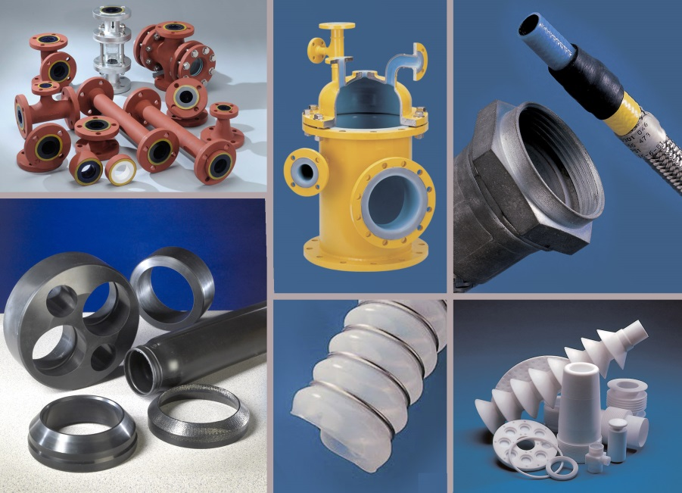
At Achema 2018 AGC Chemicals Europe is presenting current developments and applications of its extensive product portfolio of Fluon® fluoropolymers and AFLAS® fluoroelastomers. In addition the Japanese company, AGC Technology Solutions, is presenting its full range of glass-lined, corrosion-proof and chemically resistant pipe systems and fittings.
Photo: AGC Chemicals Europe
Dear colleagues,
Press releases from AGC Chemicals Europe including text and pictures in printable resolution
can be downloaded from: www.konsens.de/AGC-Chemicals.html

