Mersalen® MDPE ReCompound from post-consumer scrap allows production of high-quality extrudates
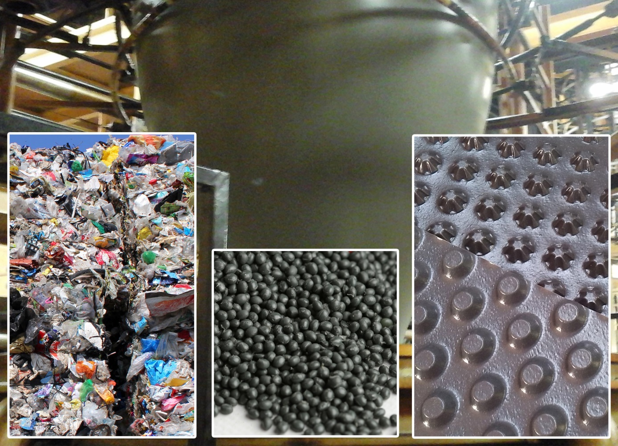
Modern recycling technology means that Mersalen® MDPE ReCompounds, which are based on post-consumer film scrap, are suitable for demanding extrusion applications such as blown and flat films, for example usable as sheeting or dimpled sheets in construction. Photo © APK
Merseburg/Germany, September 2015 — Recycling specialist APK has developed a technology capable of producing particularly high quality recycled regranulates from post-consumer film scrap originating from Germany's Dual System collection scheme (DSD). This scrap, known as fraction 310, consists of pieces of PE and PP film with a greater or lesser degree of contamination which is supplied to APK in bale form. The products leaving the elaborate cleaning, separation and recycling process are Mersalen® LDPE ReCompounds and now also the particularly readily processable MDPE ReCompounds in pellet form. Thanks to their good properties with high batch-to-batch consistency and continuous availability, these products are proving to be in high demand as raw materials for a variety of applications.
Mersalen® MDPE in particular, which has been available since mid 2015, offers processing and service characteristics which have not previously been achieved with post-consumer recycled material. As a result, applications include blown films with thicknesses of 50 µm upwards which are used, among other things, for producing barrier membranes for construction, heavy duty films and recycling sacks. Further applications include sturdy, possibly coextruded, flat films which can be converted for example into dimpled sheets for construction, non-pressurised piping and extrusion-blow moulded parts such as containers with a capacity of up to 1.5 litres.
Particular advantages for HDPE processors using this MDPE ReCompound as an admixture in film extrusion are the higher achievable draw-off speeds in comparison with pure HDPE, a wider processing window and processing temperatures which may be as much as 25°C lower, so helping to cut manufacturing energy inputs. Mersalen® MDPE ReCompounds thus complement Mersalen® LDPE grades, which are primarily processed by injection and compression moulding into pallets and thick-walled mouldings such as grass pavers but are also suitable as an admixture in the production of films with thicknesses of >180 µm.
To achieve the particularly high quality of Mersalen® MDPE ReCompounds, APK has continuously been investing in its facilities. For instance, since mid 2015, the company's Merseburg site has had a modern recycling line with a capacity of 24 tonnes per day which is capable of meeting the most demanding requirements. This new facility is in addition to the two Sicoplast systems already present on the site. In addition to high performance washing and drying installations, the line includes an Intarema 1512TVEplus® recycling extruder from EREMA. This extruder has excellent mixing and homogenising performance, a 110 µm melt filter and effective melt degassing and is thus specifically designed for converting problematic feedstock into high-quality pellets. The resultant MDPE ReCompounds are particularly clean, contain little or no internal or external moisture and have undergone minimal thermal damage.
As Mathias Nobis, manager of APK's south-west sales office, says: "Our Mersalen® MDPE ReCompounds, which are based on post-consumer film scrap and are designed for demanding processing technologies and applications, are meeting growing demand from the building industry and other sectors. Just a few months into production on an industrial scale, we are already supplying increasing volumes to a solid customer base and from 2016 we will also be able to meet demand for silo delivery."
Mersalen® LDPE and the new MDPE ReCompounds are part of APK's wide range of PP and PE ReCompounds and regranulates, which are available in both standard and custom grades.
APK Aluminium und Kunststoffe AG was founded in 2008, employs over 100 staff and has more than 62,000 m² of production, research & development and administration facilities on its Merseburg site, where it converts pre- & post-consumer plastic scrap into high-quality plastics (MDPE, HDPE, PP), blends and compounds.
One development project which will shortly reach market maturity involves separating components from various material streams in the packaging or automotive industries and then recycling the plastics content to produce raw materials with properties identical to virgin material (newcycling). APK is carrying out this basic development project using proprietary chemical/physical technologies and a pilot plant financed by MIG Fonds and AT Newtec.

Further information:
Mathias Nobis
APK Aluminium und Kunststoffe AG, south-west office
Tel.: +49 6202-74369, Email: mathias.nobis@apk-ag.de
Editorial contact and voucher copies:
Dr. Jörg Wolters
Konsens PR GmbH & Co. KG, Hans-Kudlich-Straße 25,
D-64823 Groß-Umstadt
Tel.: +49 (0) 60 78/93 63-0, Fax: -20, Email: joerg.wolters@konsens.de

This press release as a .doc file and the photo in print-ready resolution can be downloaded from: www.konsens.de/apk.html

