Julien Noel Named Vice President / General Manager of Buehler, an ITW Company
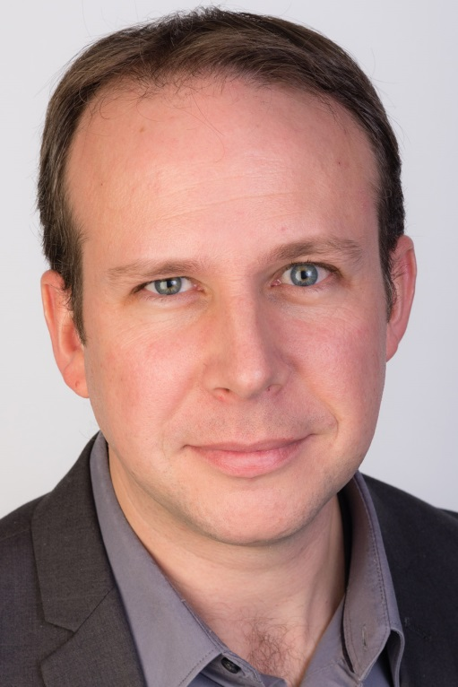
Julien Noel, Vice President/General Manager at Buehler. ©Buehler
Esslingen/Germany, February 2019 – ITW Test and Measurement Group President Yahya Gharagozlou has named Julien Noel Vice President / General Manager of the Buehler worldwide division. Buehler (www.buehler.com) is an ITW company and a premier manufacturer of scientific equipment, consumables and accessories for metallography and materials analysis, including a broad portfolio of hardness testers and hardness testing systems used in high-volume industrial production laboratories, universities and research/development organizations. Julien Noel replaces Meredith Platt, who has been transferred to ITW's Automotive segment, taking up the role of Vice President/General Manager for the worldwide Seats, Safety, and Motion division.
Julien Noel has been at Buehler since 2015 where he most recently served as the Americas Commercial Director in addition to Global Director of Strategy and Innovation. Noel came to ITW in 2010 during the acquisition of North Star Imaging, a provider of complete system solutions for X-ray testing and computed tomography (CT), where he last held the position of a General Manager for Europe. Prior to that, he was Business Manager for Digisens and Professor at the Grenoble School of Management in France.
Noel comments: “I am excited to take on this crucial leadership role for Buehler. During the last few years we provided clarity in the company strategy and created innovative solutions to help manufacturers that demand excellence. We developed successful new products, streamlined online shopping and improved our customer care/service offering. Together with the Buehler employees I look forward to continuing on the path to create superior products while meeting delivery and service expectations for our quality conscious customers globally.”
Buehler – ITW Test & Measurement GmbH, Esslingen/Germany, has been a leading manufacturer of instruments, consumables and accessories for metallography and materials analysis since 1936, and also supplies a comprehensive range of hardness testers and hardness testing systems. A tight network of branch offices and dealers means our customers can depend on professional assistance and service around the world. The Buehler Solutions Center in Esslingen and further centers of this kind in Europe and elsewhere can offer all kinds of assistance with application questions or with devising reproducible preparation procedures.
Buehler is part of the Test and Measurement Segment of the US company Illinois Tool Works (ITW) with some 100 decentralized business units in 52 countries and around 51,000 employees.
Editorial contact and voucher copies:
Dr.-Ing. Jörg Wolters, Konsens PR GmbH & Co. KG,
Hans-Kudlich-Straße 25, D-64823 Groß-Umstadt – www.konsens.de
Tel.: +49 (0) 60 78 / 93 63 - 0, Fax: - 20, Email: mail@konsens.de
Dear colleagues, Press releases from Buehler including text and pictures in printable resolution can be downloaded from: www.konsens.de/buehler.html: www.konsens.de/buehler.html

