Ettlinger at Plast 2018
Rich in tradition – now with even more power:
the ERF 350
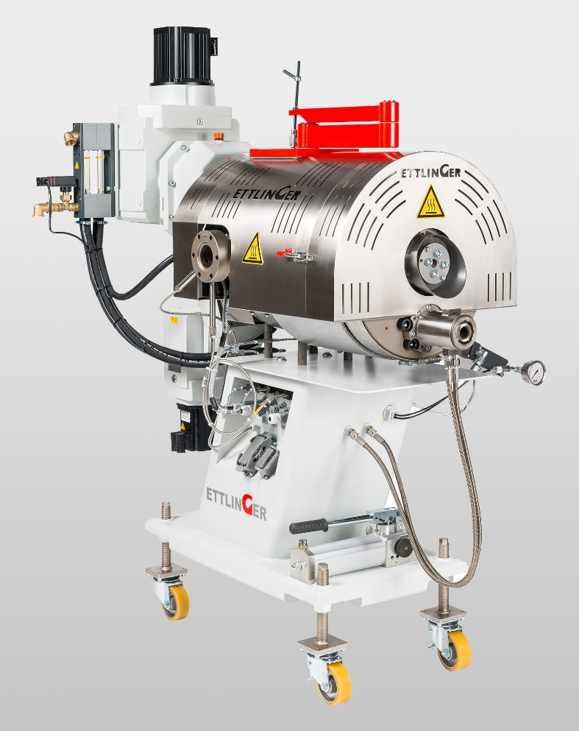
The ERF 350 melt filter for recycling contaminated plastics: technological advances enable almost 30% higher throughput. © Ettlinger
Königsbrunn / Germany, May 2018 – Ettlinger will take advantage of the upcoming Plast 2018, the international exhibition for the plastics and rubber industries in Milan from May 29 to June 1, to show its latest innovation: the ERF 350 continuous melt filter, which enables around 30% higher throughput than the predecessor ERF 250 and heralds in the next generation of Ettlinger filtration systems with several new features.
The filters in Ettlinger’s ERF series, nearly 400 of which are meanwhile operating successfully around the world, are used by recyclers and compounders to filter heavily contaminated polyolefins and polystyrenes. All ERF filters are equipped with a conical screen, which is continuously cleaned by a scraper and maintains an absolutely constant pressure. Especially with sensitive applications like film, sheet and pipe extrusion or downstream strand or underwater pelletizing systems, this is a crucial advantage.
Apart from classic recycling of polyolefins in packaging of all kinds, ETTLINGER filters have a unique capability for converting recycled automotive plastics, where paint particles have to be reliably removed from bumpers, for instance. Material flows with a high aluminum, rubber or silicone content, such as the polystyrene in yogurt pots, refrigerator scrap or ABS in electronic waste are other proven applications. Thanks to the ingenious discharge principle, ETTLINGER filters have the lowest melt losses in the industry, no matter how challenging the environment. This, in turn, leads to extremely low operating costs and a very rapid return on investment.
Depending on the application, the screen can remain in use for several weeks, or possibly months, without having to change the filter. And when the time finally comes, this can be done by a single person in less than an hour. Furthermore, the filter screen can be cleaned several times in a pyrolysis furnace before eventually being replaced.
ERF melt filters are available in three different sizes and achieve a maximum throughput of 6000 kg/h.
The melt filters in the ECO series, which are specifically designed for easy-flowing materials such as PET or PA, work according to the same principle and offer similar benefits. ECO filters are the ideal solution for manufacturing PET packaging tape as well as PET films and sheets, for fiber production or for repelletizing materials obtained from PET bottle flake. Compounders, on the other hand, choose ECO filters to separate gels and agglomerates reliably from virgin material.
Here, too, the absolutely constant pressure and low material loss – in combination with the completely airtight system – arguments which frequently tip the scales for potential buyers.
Alberto Baracco, who can draw on extensive experience in the Italian recycling market and previously worked for us for several years on behalf of another company, was appointed ETTLINGER’s representative in Italy in 2017. ETTLINGER has additionally been part of the worldwide Maag Group since the beginning of the year and profits from its close links with local agents.
***
Ettlinger Kunststoffmaschinen GmbH was founded in 1983 and is today a global player. The German company has its headquarters in Königsbrunn, not far from Augsburg. Its core competency is the development and manufacture of high performance melt filters and injection molding machines. Ettlinger has been part of the Maag Group since 2018.
■■■

More information on Ettlinger
Karsten Bräunig, Manager Sales
Ettlinger Kunststoffmaschinen GmbH, Messerschmittring 49, D-86343 Königsbrunn
Phone: +49 8231 34908 -12, Fax: -28, e-mail: karsten.braeunig@ettlinger.com
www.ettlinger.com
Editorial contact and specimen copies:
Dr. Jörg Wolters, Konsens PR GmbH & Co. KG
Hans-Kudlich-Strasse 25, D-64823 Gross-Umstadt – www.konsens.de
Phone: +49 (0) 60 78 / 93 63 - 0, Fax: - 20, e-mail: joerg.wolters@konsens.de
Ettlinger press releases (text and pictures) in German and English can be downloaded in printable quality from: www.konsens.de/ettlinger.html

