Ultra-fine microperforation sets new standards in melt filtration
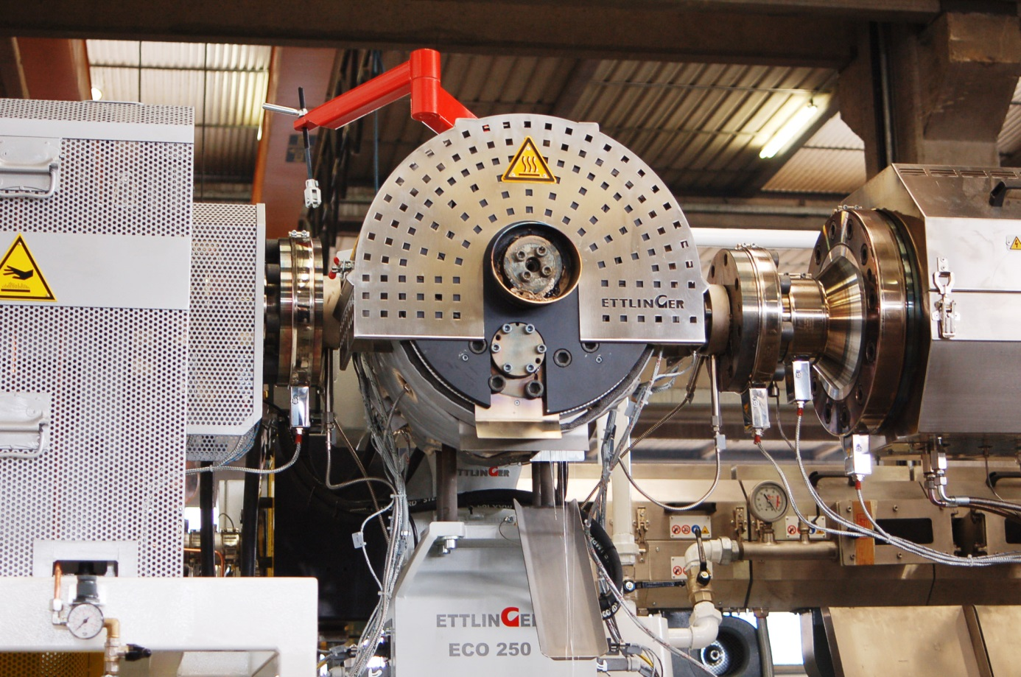
Thanks to the even smaller 60 µm screen size which is now available for Ettlinger’s ECO series, these filters are ideal whenever 100% PET bottle flake is used in thermoform sheets, packaging tape or staple fiber plants. © Ettlinger
Königsbrunn, Germany, February 2019 – With unprecedented filtration fineness of 60 µm, Ettlinger’s ECO melt filters will in the future make it easier to treat recycled material for the film, packaging tape and fiber industry and help plastics recyclers remove challenging contaminants like paints, silicones, barrier materials, cross-linked fractions and gels from the melt. In particular, the new filter screens will enable cost-efficient conversion of post-consumer PET bottle flake and fines, which generally occur in large amounts, into recycled material with excellent usage properties.
Recycled PET from post-consumer bottle flake is highly sought-after in the industry as a raw material for thermoforming packaging, fibers or packaging tapes. Against the background of increased environmental awareness, such products are also widely accepted – and in considerable demand – among consumers. Depending on the application, the recycled materials often have to meet high requirements in terms of appearance and / or mechanical properties. For instance, even food packaging made entirely from bottle flake is not allowed to contain any contaminants. Additionally, tapes or yarn which are stretched must not exhibit any defects that could cause them to tear and disrupt production.
The purity of the recycled material is central to its usability. Therefore, in the PET world, the efficiency of the melt filtration process is far more critical than usual on the recycled material production line. The screen changers and screens normally employed for this purpose have limitations here, whereas Ettlinger’s self-cleaning ECO filter systems permit compliance with even the toughest specifications. The core component of the ECO filter is a rotating, cylindrical steel screen with millions of conical holes drilled by laser. When melt flows through this screen from the outside to the inside, any contaminants are retained on the surface and continuously removed by a scraper. The decisive breakthrough as far as PET recycling is concerned was the recent market launch of a microperforation with an unprecedented filtration fineness of 60 µm.
Limitation of woven steel mesh screens
Woven steel mesh screens are made of fine metal wires. A square mesh is the simplest and most commonly encountered type. The side length of the openings corresponds to the screen’s nominal mesh size. However, in practice, a square mesh allows much larger particles (factor 1.41) to pass owing to the diagonal. Furthermore, the individual wires are only linked together loosely. As the filter cake grows and the pressure rises, some meshes may be enlarged, so that particles bigger than the nominal mesh size slip through.
Contaminants contained in the PET bottle flake such as aluminum or paper as well as “black specks” – black, degraded plastic particles that occur during the process –regularly find their way into the recycled material. The resulting scrap pushes up the cost.
This also has negative impacts on the downstream extrusion process because the build-up of a filter cake on woven steel mesh screens accompanied by strong pressure fluctuations and the need for frequent screen changes creates extra work, as does cleaning with a reverse melt flow (backflush).
Lasered microperforation is the answer
These traditional woven steel mesh screens contrast with Ettlinger’s rigid filter screens, whose laser-drilled microperforation impresses with much better separation efficiency. The woven steel mesh screens have a mesh size corresponding to the cross section of the conical holes in the filter screen, which are tapered in the direction of the melt flow. When melt flows through the screens, all contaminants larger than the hole diameter are retained on the filter surface. Thanks to the new 60 µm filtration fineness, the few residual contaminants are no longer visible to the human eye. The PET recycling process also has the basic ability to convert recycled material into new products with visual, mechanical and organoleptic properties that are indistinguishable from virgin material. The significantly reduced occurrence of black specks and other particles helps make the line more efficient because there are virtually no torn tapes or fibers; ultimately leading to substantial savings.
Added to this is the system-specific advantage of all Ettlinger-built melt filters, namely the continuous, constant filtration efficiency over several weeks or months without any process interruptions. They work according to the principle that contaminants are removed from the microperforated filter screen by a scraper, and immediately discharged, with every rotation. The filtration surface remains absolutely clean as a result and the melt filter works with a constant pressure for exceptionally long periods. Contaminants such as small elastic particles like silicone etc. which could otherwise be forced through the screen after a while, are unable to collect on the surface.
Previously unused material flows acquire commercial value
Ettlinger’s continuous melt filters regularly open up new possibilities for materials that have traditionally been considered too heavily contaminated or that contain extremely problematic contaminants. The new 60 µm filter screen makes the use of PET fines from recycled bottles an even more commercially attractive option. These fines occur during the sorting, grinding and washing processes and tend to be contaminated with large amounts of paper and aluminum. Although up to 20 tons of fines per month are generated even in small PET bottle recycling plants, this material is sold at a low price for want of an alternative. Ettlinger’s continuous, high speed ECO melt filter will let customers convert their PET material flows into an even higher quality – and hence more profitable – end product.
Ettlinger Kunststoffmaschinen GmbH was founded in 1983 and today is a global player in the development and manufacture of high performance melt filters and injection molding machines. With its headquarters in Königsbrunn, not far from Augsburg/Germany, Ettlinger has been part of the Maag Group since 2018.
Maag is a worldwide leading manufacturer of gear pumps, pelletizing and filtration systems and also pulverizers for sophisticated applications in the synthetic, chemical, petrochemical, pharmaceutical and food industries.
Dover is a diversified global manufacturer with annual revenue of approximately $7 billion. We deliver innovative equipment and components, specialty systems, consumable supplies, software and digital solutions, and support services through three operating segments: Engineered Systems, Fluids and Refrigeration & Food Equipment. Dover combines global scale with operational agility to lead the markets we serve. Recognized for our entrepreneurial approach for over 60 years, our team over 24,000 employees takes an ownership mindset, collaborating with customers to redefine what's possible. Headquartered in Downers Grove, Illinois, Dover trades on the New York Stock Exchange under "DOV." Additional information is available at dovercorporation.com.
More information on Ettlinger
Karsten Bräunig, Manager Sales
Ettlinger Kunststoffmaschinen GmbH, Messerschmittring 49, D-86343 Königsbrunn
Phone: +49 8231 34908 -12, Fax: -28, e-mail: karsten.braeunig@maag.com
www.ettlinger.com
Editorial contact and specimen copies:
Dr. Jörg Wolters, Konsens PR GmbH & Co. KG
Hans-Kudlich-Strasse 25, D-64823 Gross-Umstadt – www.konsens.de
Phone: +49 (0) 60 78 / 93 63 - 0, Fax: - 20, e-mail: joerg.wolters@konsens.de

Ettlinger press releases with pictures in printable quality can be downloaded from: www.konsens.de/ettlinger.html

