Hot runner system from HRSflow for Class A vehicle windows made of polycarbonate
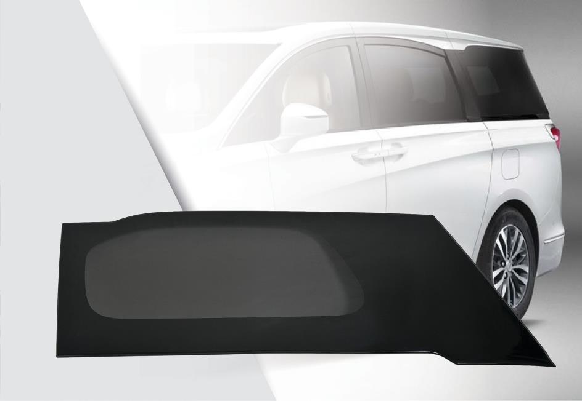
The rear-quarter window of a large MPV is a two-component injection molding part, produced with a Class A surface using the precisely controllable FLEXflow valve gate system from HRSflow.
© HRSflow
San Polo di Piave/Italy, January 2018 --- For the two-component injection molding of the rear-quarter windows of polycarbonate (PC) for the Buick GL8 and GL8 Avenir MPVs (multi-purpose vehicles), Chinese Tier 1 supplier Shentong uses two hot runner systems from HRSflow. One is for producing the transparent first component and the other for the partial, seamless overmolding with a dark-colored PC around the edges. Both systems integrate the programmable FLEXflow valve gate technology, which enables the manufacturer to achieve the outstanding surface quality specified by the OEM for these parts. With dimensions of 1,200 mm x 460 mm, it is currently the world's largest molding of its kind. Furthermore, FLEXflow helps to ensure that the windows – which are around 40 % (3 kg) lighter than comparable parts made of glass – have very high fitting precision for unproblematical assembly with minimum warpage and very tight tolerances. During the course of the project development, HRSflow supported the converter with extensive Moldflow simulations during optimization of the production parameters for these large, asymmetrical parts.
The two hot runner systems developed by HRSflow each have a hot runner manifold with ten servo-electrical drives for the nozzles with conical valve gate, integrated into the clamp platen. The FLEXflow technology from HRSflow used to control the sequential injection process makes it possible to coordinate every single individually driven needle precisely to the process and to open and close it with selectable speeds. This allows absolute precision control both of the melt flow in the individual hot runner nozzles and of the volume flow in the overall cavity so that it is filled evenly and homogeneously. Thanks to the gentle opening and closing of the needles, there is none of that undesired pressure drop or changes in temperature and flow velocity as can occur with conventional cascade injection molding during the sequentially abrupt switching on of the hot runner nozzles. This thus also eliminates unsightly flowmarks on the molded part. The overall result is Class A molding surface with no optically relevant defects. The main applications of the FLEXflow technology are the injection molding of high-quality complex automotive parts including large-area exterior and interior components such as spoilers, front ends, instrument panel supports, door trim and headlights as well as wide trunk taillights, plus the rear-quarter windows described here made of transparent polycarbonate (PC).
HRSflow (www.hrsflow.com) is a division of INglass S.p.A. (www.inglass.it), headquartered in San Polo di Piave/Italy. It is specialized in the development and production of advanced and innovative hot runner systems for the injection molding industry. The group of companies has more than 1,100 employees and is present on all the major global markets. HRSflow produces hot runner systems at its European headquarters in San Polo di Piave/Italy, in Asia at its plant in Hangzhou/China and at its facility in Byron Center near Grand Rapids, MI, USA.
Contact and further information
HRSflow, Via Piave 4, 31020 San Polo di Piave (TV), Italy
Phone: +39 0422 750 111, Email: info@hrsflow.com, www.hrsflow.com
Erica Gaggiato, Communication Dept.
Phone: +39 0422 750 120, Email: erica.gaggiato@inglass.it
Editorial contact and voucher copies
Dr.-Ing. Jörg Wolters, Konsens PR GmbH & Co. KG,
Hans-Kudlich-Straße 25, D-64823 Groß-Umstadt, Germany – www.konsens.de
Tel.: +49 (0) 60 78 / 93 63 0, Email: mail@konsens.de
Dear Colleagues, Press releases from HRSflow with text (German and English)
as well as pictures in print-ready resolution are available to download from:
www.konsens.de/hrsflow.html

