Space-saving nozzles and insulating pressure blocks enhance application convenience in hot runner injection molding
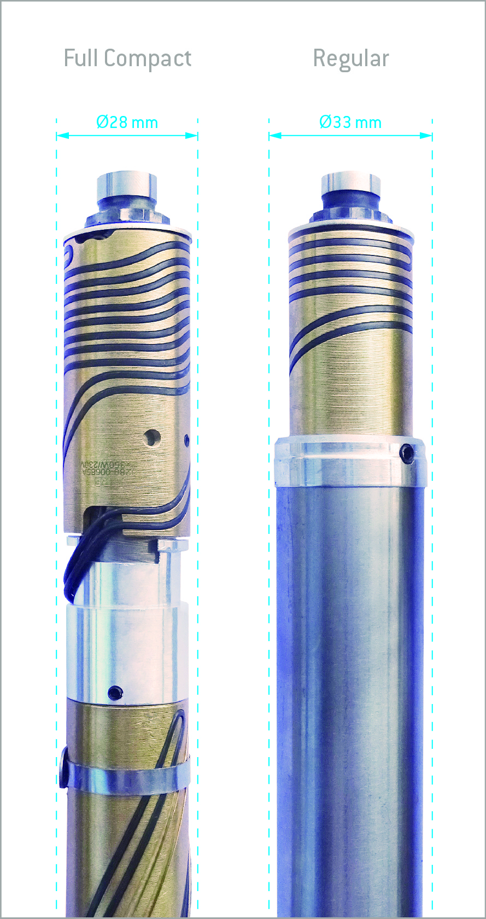 | 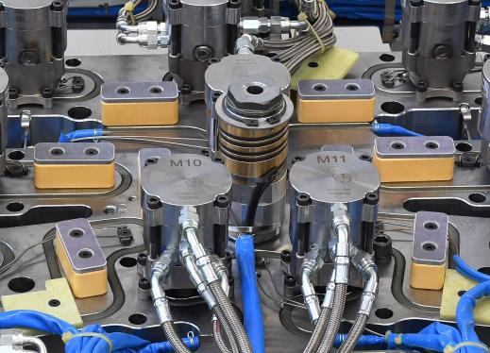
The new Full Compact Nozzles from HRSflow have a nozzle seat diameter of 28mm over their entire length, which is 5 mm less than the equivalent standard nozzle.  © HRSflow | The new Pressure Block clamping plates from HRSflow are made of materials with very low thermal conductivity. They bring about a distinct increase in mold stiffness, keeping at the same time an optimal thermal profile along the whole hot runner system.  © HRSflow
San Polo di Piave/Italy, January 2018 --- Two new developments from the Italian hot runner specialist HRSflow, which have recently reached production maturity, help to make the injection molding of high-quality parts even easier and more reliable. While the new Full Compact Nozzles allow far smaller cavity-to-cavity distances, the equally new Pressure Block clamping plates help to bring about a distinct increase in mold stiffness ensuring an optimal thermal profile in the hot runner system.
For smaller cavity-to-cavity distances
With the new Full Compact Nozzles, HRSflow has succeeded in accommodating all the heating elements of the previous standard Pa type (screwed-in nozzles for shot weights up to 200 g) in a space-saving design with a nozzle seat diameter of only 28 mm along the entire length instead of 33 mm with the conventional design. The needle tip and end ring of the new screw-in nozzles are unchanged. With internal diameters of 6 mm, 8 mm and 10 mm and nozzle lengths from 75 mm to 450 mm, they can be provided with one or two heating zones. They are also available in Classic Line and Fail Safe versions, the latter with two heating devices and two thermocouples. The Full Compact Nozzles are also suitable for reverse gating of moldings and for all gating configurations (torpedo, free flow and valve gating). Their maximum working pressure is 1,800 bar. Typical applications include small, complex-shaped parts such as loudspeaker grilles for vehicle interiors.
For higher mold stiffness and uniform temperature profiles
High clamp plate stiffness under load and an optimum temperature profile in the hot runner system play a key role for the quality of a molding. If this profile is not uniform, it can result in unbalanced spreading of the flow front, warpage and surface marks. The problem can be remedied by the new Pressure Blocks developed by HRSflow, meeting both requirements to ensure an optimal molding process. Produced from two special materials with low thermal conductivity, they act in two ways. Positioned on both sides of the hot runner, they firstly increase the stiffness of the platen so that the latter becomes less deformed under load. This results in moldings of constant thickness within the narrowest of tolerances and without any flash formation. Secondly, they prevent heat transfer between this and the platen, which makes the temperature distribution in the hot runner far more uniform. The Pressure Blocks can be arranged in any desired position between the hot runner system and the mold (but not above the heating unit) without influencing the temperature profile. Depending on the customer's wishes, they are available with or without an adjusting plate and with thicknesses of 20 mm (240 °C maximum runner temperature, 50 °C maximum mold temperature) or 30 mm (300 °C/100 °C).
HRSflow (www.hrsflow.com) is a division of INglass S.p.A. (www.inglass.it), headquartered in San Polo di Piave/Italy. It is specialized in the development and production of advanced and innovative hot runner systems for the injection molding industry. The group of companies has more than 1,100 employees and is present on all the major global markets. HRSflow produces hot runner systems at its European headquarters in San Polo di Piave/Italy, in Asia at its plant in Hangzhou/China and at its facility in Byron Center near Grand Rapids, MI, USA.
Contact and further information
HRSflow, Via Piave 4, 31020 San Polo di Piave (TV), Italy
Phone: +39 0422 750 111, Email: info@hrsflow.com, www.hrsflow.com
Erica Gaggiato, Communication Dept.
Phone: +39 0422 750 120, Email: erica.gaggiato@inglass.it
Editorial contact and voucher copies
Dr.-Ing. Jörg Wolters, Konsens PR GmbH & Co. KG,
Hans-Kudlich-Straße 25, D-64823 Groß-Umstadt, Germany – www.konsens.de
Tel.: +49 (0) 60 78 / 93 63 0, Email: mail@konsens.de
Press releases from HRSflow with text (German and English) as well as pictures in print-ready resolution are available to download from: www.konsens.de/hrsflow.html

