NEWS RELEASE

HRSflow at Moulding Expo 2017 – Hall 6, Booth D41
HRSflow multicavities hot runner solutions

San Polo di Piave/Italy, May 2017 – At this year's Moulding Expo at Stuttgart/Germany, Italian hot runner specialist HRSflow (www.hrsflow.com) will present a new family of hot runner solutions for multi-cavity molds on Booth D41 in Hall 6. The multicavity series is suitable for the large-scale production of injection molded products wherever short cycle times and high surface quality are specified, for example in medical applications, cosmetic articles, caps and closures, and packaging. In addition, HRSflow will show visitors some of the latest results from its partnership with Plastic Technologies, Inc. (PTI), a global leader in plastic packaging development for single-serve beverage and food capsules.

The hot runner nozzles of the Reinforced range are designed for high injection pressures and are suitable for thin and thick-walled applications. Furthermore, they are noted for the very high wear resistance of the nozzle tips. They are available in three specifications: Reinforced-T, Reinforced-M and Reinforced-S.

- Reinforced-T has been developed specifically for the injection molding of thin-walled articles. These nozzles are also suitable for decorative injection molding using the IML process (in-mold labelling). Because of their shape and homogenous temperature profile, very high injection speeds and thus short cycle times are possible. This prevents overheating and thus damage or discoloration of the IML label and therefore ensures high process stability.
- The Reinforced-M nozzle is ideal for processing polyesters into thick-walled parts with a high-gloss surface, e.g. cosmetic packs, household articles or products for medical technology. Here, wall thicknesses of 20 mm and more can be produced without problem.
- Reinforced-S nozzle has also been developed for thick-walled injection molded parts with a wall thickness of up to 20 mm. This nozzle has been designed specifically for the injection molding of Surlyn®, a highly transparent packaging material from DuPont™.

A recent application example for the new hot runner nozzles of the Reinforced range is a cover cap for spirits, molded in PP filled with Fe₂O₃ and then partially metallized. Because the material is very abrasive due to the filler, the nozzle tip needed to have high wear resistance. The molded part has a wall thickness of up to 8 mm at the gating point and weighs 19 g. It must have neither sink marks nor flow lines nor any mat or shiny areas so as to ensure a uniform, high-quality surface after metallization.

Reduced time-to-market for beverage and food capsules
In view of the explosive growth of single-serve beverage and food capsules, HRSflow and Plastic Technologies, Inc. (PTI) set up a partnership in 2016. The aim is to offer brand owners a turnkey solution for commercializing their products. The significant technical knowledge both companies have in this area will help improve the speed to market and drive commercial success.

About HRSflow
HRSflow (www.hrsflow.com) is a division of INglass S.p.A. (www.inglass.it), headquartered in San Polo di Piave/Italy. It is specialized in the development and production of advanced and innovative hot runner systems for the injection molding industry. The group of companies has more than 1,100 employees and is present on all the major global markets. HRSflow produces hot runner systems at its European headquarters in San Polo di Piave/Italy, in Asia at its plant in Hangzhou/China and at its facility in Byron Center near Grand Rapids, MI, USA.

______________

Contact and further information
Grit Feistkorn, Automotive Marketing Manager
Phone: +49 160 7407058, email: grit.feistkorn@hrsflow.com
HRSflow, Via Piave 4, 31020 San Polo di Piave (TV), Italy
Phone: +39 0422 750 111, E-Mail: info@hrsflow.com, www.hrsflow.com

Editorial contact and voucher copies
Barbara Welsch, Konsens PR GmbH & Co. KG,
Hans-Kudlich-Straße 25, D-64823 Groß-Umstadt/Germany – www.konsens.de
Phone: +49 (0) 60 78 / 93 63 - 14, Fax: - 20, E-Mail: mail@konsens.de

Dear Colleagues,
Press releases from HRSflow with text (German and English)
as well as pictures in print-ready resolution are available to download from:
www.konsens.de/hrsflow.html

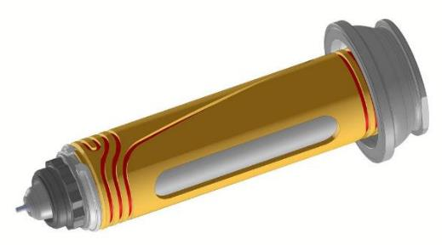

The new hot runner nozzles of the Reinforced range has been specifically developed for the thin-wall injection molding of packaging and the production of thick-walled parts
(Photo: HRSflow)

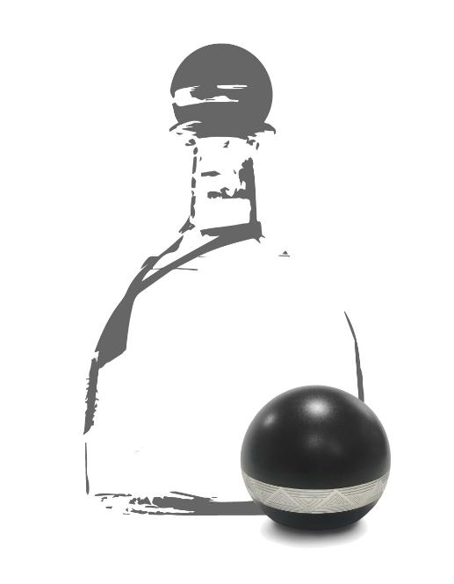
Cover cap for spirits: Molded in PP filled with Fe₂O₃ and then partially metallized (Collage: HRSflow).

