HRSflow at Fakuma 2017
Hot runner solutions for complex challenges
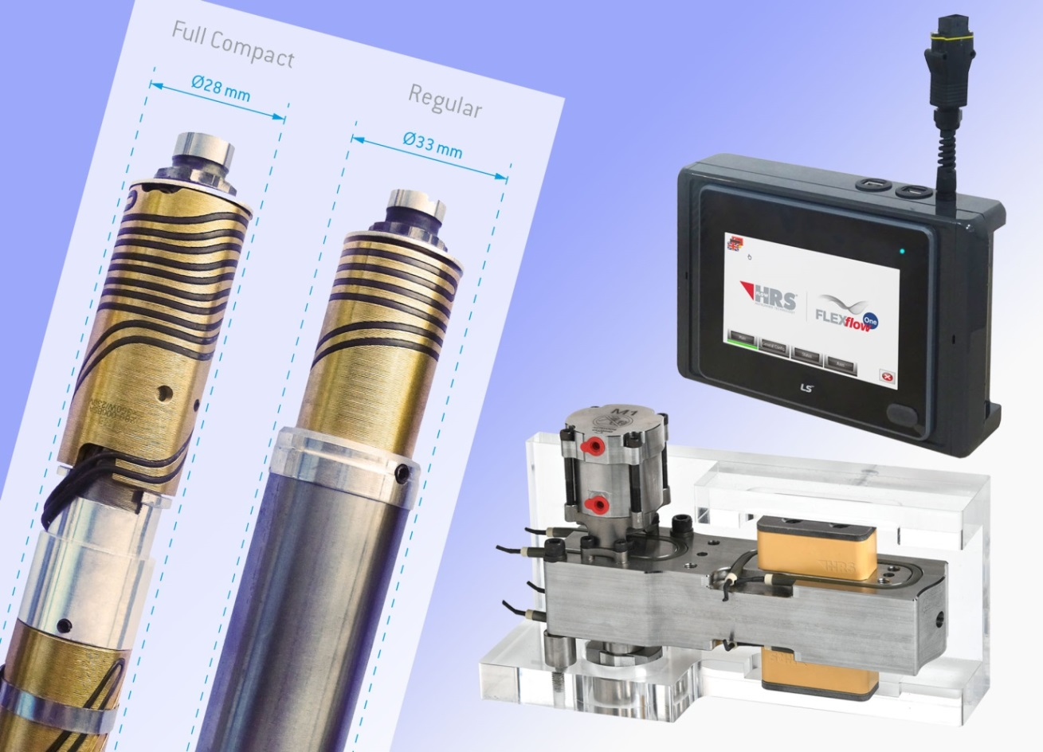
Highlights at HRSflow’s booth at Fakuma 2017 will include the new range of space-saving Full Compact Nozzles (left), the servo driven FLEXflow One hot runner technology which – set by an External Smart Interface (top right) – does not require an additional control unit, as well as newly developed Pressure Block clamping plates (bottom right), which, positioned between hot runner system and mold, support a uniform temperature profile and help to increase the mold stiffness.
© HRSflow
San Polo di Piave, Italy, August 2017 --- HRSflow's presence (www.hrsflow.com) at this year's Fakuma at booth 2217, hall A2 will focus on servo driven FLEXflow One hot runner technology which does not require an additional control unit during the injection process, and the new range of Full Compact Nozzles with a reduced constant external diameter over their length. Thanks to newly developed pressure blocks, the hot runner can be used to provide support in the mold, while the new Thread Safe Kit prevents damage during disassembly of screwed-in hot runner nozzles.
Flexibly programmable, operated without control unit
Premiered at K2016, the servo driven FLEXflow One needle valve systems for hot runner nozzles have a simple driver module that replaces an otherwise necessary control unit. In its current design, this module comes with a default setting that fully opens/closes the needle. Using an External Smart Interface (ESI) that is connected for this purpose, needle stroke and velocity can be individually set for specific applications, including multiple steps if required. Up to 24 valve pins per system can be individually programed using this ESI. Once these parameters have been saved in the driver module, the system is ready to produce high-quality molded parts consistently without a control unit.
As an additional safety factor over hydraulically driven systems, a maximum torque is set for the servomotor at the time of manufacture. When this value is reached, the electronics shut down to prevent damage to the hot runner system and mold and thus long, costly production downtime. Beyond, all FLEXflow One systems are connected with a Safety Interface Box (SIB) which communicates with the injection molding machine's controller to ensure safe working conditions.
Tight cavity spacing
Full compact nozzle is HRSflow's name for a newly developed family of screwed-in hot runner nozzles which achieves a space-saving heating system, the nozzle seat diameter having been reduced from 33 mm to 28 mm over its entire length. They are optimized for producing small, delicate parts such as loudspeaker grilles and are also suitable for reverse gating from the ejector side. Lengths range from 75 mm to 450 mm with internal diameters of 6, 8 and 10 mm. They can be equipped with one or two heating zones and are available in Classic Line and Fail Safe versions, the latter with two heating devices and two thermocouples. Available gating options are torpedo, free flow and valve gating.
Uniform temperature profile
HRSflow's recently introduced Pressure Block clamping plates are positioned between the hot runner system and mold where, thanks to their low thermal conductivity, they ensure a more uniform temperature profile in the hot runner system and help to bring about a distinct increase in mold stiffness. They can be flexibly positioned without any negative impact on the temperature profile of the hot runner system.
Simplified maintenance
Another recently introduced product, the Thread Safe Kit unscrewing aid, reduces maintenance costs by helping to ensure easy nozzle removal without thread damage. In particular when processing critical thermoplastics such as PMMA and PC, it stops the screwed-in nozzle from seizing.
HRSflow (www.hrsflow.com) is a division of INglass S.p.A. (www.inglass.it), headquartered in San Polo di Piave/Italy. It is specialized in the development and production of advanced and innovative hot runner systems for the injection molding industry. The group of companies has more than 1,100 employees and is present on all the major global markets. HRSflow produces hot runner systems at its European headquarters in San Polo di Piave/Italy, in Asia at its plant in Hangzhou/China and at its facility in Byron Center near Grand Rapids, MI, USA.
Contact and further information
HRSflow, Via Piave 4, 31020 San Polo di Piave (TV), Italy
Phone: +39 0422 750 111, Email: info@hrsflow.com, www.hrsflow.com
Erica Gaggiato, Communication Dept.
Phone: +39 0422 750 120, Email: erica.gaggiato@inglass.it
Editorial contact and voucher copies
Dr.-Ing. Jörg Wolters, Konsens PR GmbH & Co. KG,
Hans-Kudlich-Straße 25, D-64823 Groß-Umstadt, Germany – www.konsens.de
Tel.: +49 (0) 60 78 / 93 63 0, Email: mail@konsens.de
Dear Colleagues, Press releases from HRSflow with text (German and English)
as well as pictures in print-ready resolution are available to download from:
www.konsens.de/hrsflow.html

