HRSflow at NPE2018
Visit our project partners to experience the FLEXflow technology live

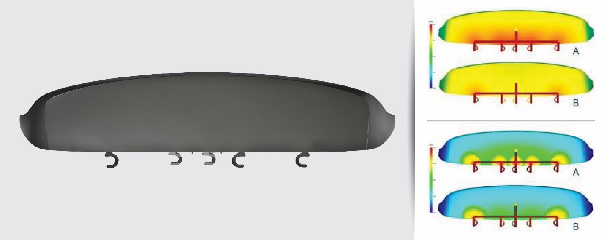
Spoiler test mold, equipped for cascade injection molding with a fivefold hot runner (left) and Moldflow simulation of the injection (top right) and holding pressure phase (bottom right) in conventional cascade injection molding (A) and with the FLEXflow valve gate system (B). With FLEXflow, the pressure in the cavity is far more homogeneous and the pressure level overall is lower. © HRSflow
San Polo di Piave, Italy, May 7th, 2018 – At NPE 2018, on Stand W991, West Hall Level 2, Italian hot runner specialist HRSflow will show its FLEXflow technology comprising servo-electric valve gate solutions for automotive and non-automotive applications. Visitors to the show will have an opportunity to experience these innovative systems live, in four demonstrations. These tailor-made hot runner solutions, with which the mold-filling process can be optimally controlled and documented, can be incorporated into the production of complex, large-format components where particularly high demands are made on quality. The technology has been developed through close cooperation between HRSflow and partners from materials production, mold manufacture and injection molding machine production.
- Wittmann Battenfeld will demonstrate on Stand W3742 the production of an automotive spoiler that meets the highest specifications on surface quality using a FLEXflow 5 drop hot runner system. The key properties are a uniform flow front and pressure distribution during injection, the avoidance of pressure and flow lines, and the optimization of color changes.
- Yizumi will manufacture on Stand W3343 a lightweight tool case of micro-cellular foam. For this, the company uses its FoamPro foaming process based on the MuCell® technology on a two-platen injection molding machine using a FLEXflow triple hot runner system with back injection. The finished part is noted for its high-quality, finely structured surface.
- KraussMaffei will demonstrate on Stand W403 the complex production of an automotive center console armrest for next generation lightweight vehicles. This molded part, achieved in cooperation with moldmaker Proper Tooling, is based on a thermoformed composite sheet structure, which is first covered with polypropylene and subsequently overmolded with a thermoplastic elastomer. A double and triple FLEXflow system from HRSflow are used for this.
- ENGEL will produce on Stand W3303 an interior vehicle component with optimized tactile properties. The part takes on its high-quality grained surface with the help of the in-mold graining technology. It works with the back injection of PP in the MuCell® process with a five-fold FLEXflow system, and also uses DecoJect© films from Benecke Kaliko.
FLEXflow: simple, safe and clean
The servo-electric valve gate system of the innovative FLEXflow technology from HRSflow offers the possibility to control the stroke, velocity and force for each valve pin independently of each other during the opening and closing phases. The advantages over conventional pneumatically or hydraulically driven needle valve systems include the ability to produce streak-free Class A surfaces, reduce warpage and ensure easy maintenance and user friendliness. FLEXflow thus provides an answer to the constantly growing demand in the automotive industry for an accurate, easy and flexible control of the pressures and flow rates during the entire mold-filling process. This technology makes an important contribution to meeting the highest quality production requirements – and combines it with outstanding reproducibility.
HRSflow (www.hrsflow.com) is a division of INglass S.p.A. (www.inglass.it), headquartered in San Polo di Piave/Italy. It is specialized in the development and production of advanced and innovative hot runner systems for the injection molding industry. The group of companies has more than 1,100 employees and is present on all the major global markets. HRSflow produces hot runner systems at its European headquarters in San Polo di Piave/Italy, in Asia at its plant in Hangzhou/China and at its facility in Byron Center near Grand Rapids, MI, USA.

Contact and further information
HRSflow, Via Piave 4, 31020 San Polo di Piave (TV), Italy
Phone: +39 0422 750 111, Email: info@hrsflow.com, www.hrsflow.com
Erica Gaggiato, Communication Dept.
Phone: +39 0422 750 120, Email: erica.gaggiato@inglass.it
Editorial contact and voucher copies
Dr.-Ing. Jörg Wolters, Konsens PR GmbH & Co. KG,
Hans-Kudlich-Straße 25, D-64823 Groß-Umstadt, Germany – www.konsens.de
Tel.: +49 (0) 60 78 / 93 63 0, Email: mail@konsens.de
Press releases from HRSflow with text (German and English) as well as pictures in print-ready resolution are available to download from: www.konsens.de/hrsflow.html

