FLEXflow hot runner system enables gas-assisted injection molding of Class A surface chainsaw handle
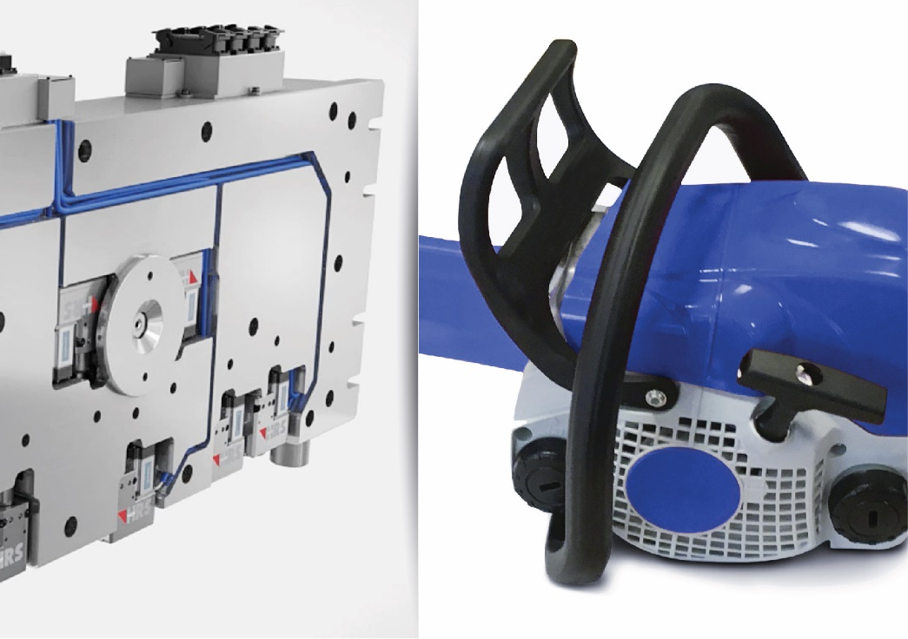
The FLEXflow hot runner technology from HRSflow with its servo-electric valve gates is an ideal solution for the gas-assisted injection molding of the hollow handle for a chainsaw. Real application. The picture of FLEXflow Technology is for illustration purpose only. © HRSflow
San Polo di Piave, Italy, May, 2018 – A hollow handle for a chainsaw, manufactured by gas-assisted injection molding, is one of the latest examples of the use of HRSflow's innovative FLEXflow technology. This servo-electric programmable valve gate solution for hot runner systems allows precision control and monitoring of the melt flow during filling of the mold cavity.
The lightweight yet very stable handle is made of a highly impact-resistant, easy-flow PA6-GF30 %. The mold is provided with two hot runner needle valve nozzles of the MA series from HRSflow with a conical seal. They are designed for medium shot weights and optimized for the polymer used in this particular application. While the melt is being injected through these two nozzles, the servo-electric drive of the valve pins – the big feature of the FLEXflow technology – makes it possible to control the stroke, velocity and force independently of one another for each individual pin during the opening and closing phases. This ensures an optimum mold-filling process.
With the gas-assisted injection molding technology, nitrogen is subsequently injected under high pressure into the injected melt, which is consequently pushed against the cavity wall. Through combination with the FLEXflow hot runner technology, the formation of flow marks and other surface defects that can otherwise occur when processing glass fiber-reinforced thermoplastics can be reliably avoided. The result is an injection-molded part that is hollow and thus lightweight, and has good shrink resistance and low warpage. It also boasts high flexural strength and a streak-free Class A surface.
HRSflow (www.hrsflow.com) is a division of INglass S.p.A. (www.inglass.it), headquartered in San Polo di Piave/Italy. It is specialized in the development and production of advanced and innovative hot runner systems for the injection molding industry. The group of companies has more than 1,100 employees and is present on all the major global markets. HRSflow produces hot runner systems at its European headquarters in San Polo di Piave/Italy, in Asia at its plant in Hangzhou/China and at its facility in Byron Center near Grand Rapids, MI, USA.
Contact and further information
HRSflow, Via Piave 4, 31020 San Polo di Piave (TV), Italy
Phone: +39 0422 750 111, Email: info@hrsflow.com, www.hrsflow.com
Erica Gaggiato, Communication Dept.
Phone: +39 0422 750 120, Email: erica.gaggiato@inglass.it
Editorial contact and voucher copies
Dr.-Ing. Jörg Wolters, Konsens PR GmbH & Co. KG,
Hans-Kudlich-Straße 25, D-64823 Groß-Umstadt, Germany – www.konsens.de
Tel.: +49 (0) 60 78 / 93 63 0, Email: mail@konsens.de
Press releases from HRSflow with text (German and English) as well as pictures in print-ready resolution are available to download from: www.konsens.de/hrsflow.html

