Compact technology for low-height hot runner stack molds
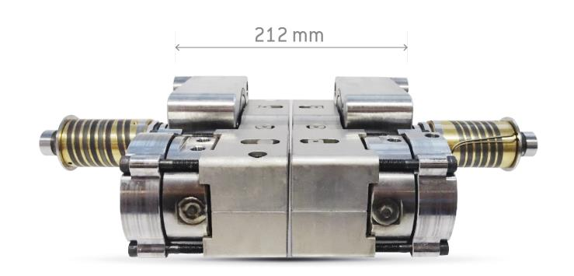
HRSflow has developed space-saving versions of the actuating cylinder for hot runner systems that enable stack molds with low plate heights. © HRSflow
San Polo di Piave/Italy, November 2018 --- Specifically for the construction of stack molds, HRSflow (www.hrsflow.com) has added to its product range a special low-height actuator for hot runner valve gate systems. The advantage of this 'Compact Stack Mold' technology is derived from the staggered arrangement of the cylinders to the side of the nozzle and the use of rocker levers to transmit the movement from the cylinder to the needle and tip solution used.
Stack molds made in this way have much lower construction heights than versions in which the cylinders and needles are aligned. The required plate thickness is then 132 mm for offset nozzles and 212 mm for in line nozzles in the case of HRSflow's Ga range designed for medium to large shot weights. Available for PP, ABS and PC/ABS, this new technology is mainly used for big automotive parts such as bumpers and non-automotive applications such as bins or pallets. Stephan Berz, Vice President HRSflow Sales, states: "Stack molds with a lower height often allow the use of smaller injection molding machines, which then lead to much lower running costs. In this way, our 'Compact Stack Tool' technology helps to make the operation of stack molds even more economical."
Stack molds…
… have two or more parting lines. This makes it possible to fill cavities arranged in a row with one shot, thus increasing productivity. Typical applications include, for example, the simultaneous manufacture of differently shaped parts that are then immediately assembled to create a sub-assembly. Although the addition of a further cavity level allows a correspondingly higher shot volume, it does not bring about any increase in the required locking forces. Nevertheless, the mold weight rises due to the larger number of plates, and the fact that the tie bar guides for the moving mold halves and the support of the plates must have sufficient stability. Because HRSflow's new, low-height 'Compact Stack Mold' technology allows thinner plates, the guide and support elements can accordingly be designed smaller, thus saving additional costs.
HRSflow (www.hrsflow.com) is a division of INglass S.p.A. (www.inglass.it), headquartered in San Polo di Piave/Italy. It is specialized in the development and production of advanced and innovative hot runner systems for the injection molding industry. The group of companies has more than 1,100 employees and is present on all the major global markets. HRSflow produces hot runner systems at its European headquarters in San Polo di Piave/Italy, in Asia at its plant in Hangzhou/China and at its facility in Byron Center near Grand Rapids, MI, USA.
Contact and further information
HRSflow, Via Piave 4, 31020 San Polo di Piave (TV), Italy
Phone: +39 0422 750 111, Email: info@hrsflow.com, www.hrsflow.com
Erica Gaggiato, Communication Dept.
Phone: +39 0422 750 120, Email: erica.gaggiato@inglass.it
Press releases from HRSflow with text as well as pictures in print-ready resolution are available to download from: www.konsens.de/hrsflow.html

