ILLIG at Interpack 2017:
IML Decoration of Thermoformed Packs on ILLIG FSL 48 Form, Fill and Seal Line
Heilbronn and Düsseldorf, May 5, 2017 – At this year's Interpack ILLIG; the systems provider for thermoforming solutions, will be presenting its thermoforming lines in their latest stage of development customized for the demands of the food and dairy industries. In focus will be the FSL 48 form, fill and seal line with multi-lane filler and integrated IML (In-Mold Labeling) station. Moreover, the Heilbronn machine manufacturer will demonstrate the latest IML-T
IC-RDM 70K production line with the compact IML RDML 70b unit for flexible decoration of nearly any cup geometry. Currently, ILLIG is the only machine manufacturer of IML-T that offers all required modules which have been optimally synchronized with one another from one source.
FSL 48 with variable filler up to hygiene class V according to VDMA
The FSL 48 form, fill and seal line developed by ILLIG is suitable for requirements by the food and particularly the dairy industry. The multi-lane filler with CIP (cleaning in place) and SIP (sterilization in place) functions can be equipped technically in such a way that it will meet the different hygiene demands by the food industry, even up to hygiene class V according to VDMA (hygienic filling machines). The hygiene levels of the machines reach from forming with sterile air, a completely closed filling range (tunnel – also available in CIP/SIP version), and with lid material sterilization by UVC radiation or H₂O₂ treatment.
In the aseptic version the formed cups (inside) undergo additionally spraying with H₂O₂ steam and subsequent drying by means of hot sterile air. Everything takes place within the closed aseptic module (filling range/filler) and there is no adverse effect on machine or surroundings.
The controlled motion sequencing of the line, which is completely servo driven, results in very smooth running. This means that even very liquid products can be filled and there is no product spilling on the sealing rims of the packs. All standard materials suitable for FFS lines can be processed on the FSL 48, such as PS, PP, multilayer materials (e.g. PS/EVOH/PE), APET and even materials made of the biopolymer PLA (polylactic acid).
The FSL 48 forming area allows a complete cycle output – e.g. twelve standard curd packs – to be placed directly in a box adapted in size to the dimensions of a Euro pallet, after filling, sealing and punching. The machine is area is suitable for the production of single or double cups, 4-up or 6-up trays by adjusting of the punching tool. Dairy products, also in different flavors, can be filled in pre-labeled packs in one machine cycle using single-lane or multi-lane fillers. Four different flavors will be filled at the same time on the line presented at Interpack, with 12-up layout, at a working speed of up to 30 cycles/min.
FSL 48 combined with IML-T: Individual labeling for the food industry
The specially designed IML unit integrated in the forming station of the FSL 48 works with printed label blanks from the magazine. Numerous decoration options can thus be realized in a simple way: One-sided, two-sided, three-sided (e.g. U-shaped), four-sided or even five-sided (including bottom decoration e.g. with integrated barcode). A great variety of cup shapes can be smoothly decorated with attractive labels in photo quality since walls don't have to be vertical for IML decoration.
Inserting of labels in the mold is an additional work step in the thermoforming process. This step is performed parallel to the ongoing forming process in the FSL 48 so the high productivity (cycle speed) is still achieved. The lower mold part is designed as a cube which turns by 90 degrees with each cycle. The labels are pre-formatted before they are inserted in the mold and held in the individual cavities by vacuum with positional accuracy.
During the subsequent forming process the label bonds true to contour and permanently with the cup wall. In principle, the cup or tray-shaped pack can be designed almost without limits. The large decoration area is a special benefit provided by IML-T technology. Subject to its geometry and properties, the label increases the strength of the whole pack. Consequently, the thickness of the packaging material used can be reduced (saving of material costs), but the required top load of the pack is still achieved. The fact that every cavity of the mold can be equipped with an individually printed label is a further benefit provided by the IML-T technology developed by ILLIG. Thus a product change can be carried out fast and with only a small effort. All conventional label materials can be processed. Thus packs can be manufactured which in principle can be recycled, provided that labels and cups are made of the same material.
Cost-effective decoration with IML thermoforming
In live demonstrations at the trade fair stand ILLIG will show practical IML-T application on the IC-RDM 70K production line together with the compact RDML 70b IML unit. The 18-up mold employed will manufacture rectangular PP cups with three different decorations. In standard operation the machine achieves an output of 17,280 cups/hour. They are decorated on all four side walls and the bottom directly during forming.
In terms of costs IML thermoforming developed by ILLIG is more favorable than IML injection molding also used for decoration of plastic packs. Most cup shapes can be flexibly decorated with labels using IML-T. Moreover, investment costs for molds and maintenance costs are lower than in injection molding. Thermoformed articles can be manufactured with thinner walls and are thus lighter than injection molded articles. And furthermore less energy is required for processing in addition to the considerably lower material consumption. IML thermoforming provides economic benefits due to more cavities per mold.
ILLIG is a leading global supplier of high-performance thermoforming machines and molds, as well as solutions for the packaging industry. The company's product and services portfolio includes the development, design, manufacture, installation and commissioning of complex production lines and components. With branches and sales agencies in over 80 countries, ILLIG is locally present in all markets around the globe. For nearly 70 years, the owner-operated enterprise has been serving its customers across the globe as a reliable partner for the cost-effective manufacturing of complex precision thermoplastic parts with innovative technology of unsurpassed quality and comprehensive worldwide after-sales support.
■■■
Further information:
Wolfgang Konrad, Head of Company Communications
ILLIG Maschinenbau GmbH & Co. KG, Robert-Bosch-Straße 10, D-74081 Heilbronn
Phone: +49 7131 505-236, Fax: -1236, Email: wolfgang.konrad@illig.de
www.illig.de

Editorial contact and voucher copies:
Georg Sposny
Konsens PR GmbH & Co. KG, Hans-Kudlich-Straße 25, D-64823 Groß-Umstadt
Tel.: +49 6078 9363-0, Fax: -20, Email: georg.sposny@konsens.de
www.konsens.de

Dear colleagues, ILLIG press releases, including text (German and English) and photos in printable resolution, are available for download at: www.konsens.de/illig.html

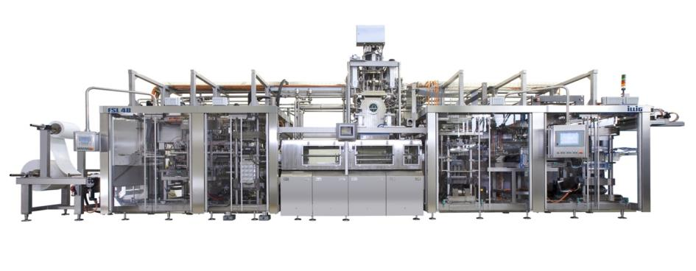

The ILLIG FSL 48 form, fill and seal line allows hygienic filling and packing, particularly of dairy products with brilliant IML decoration of the formed cups in all different shapes at the same time.

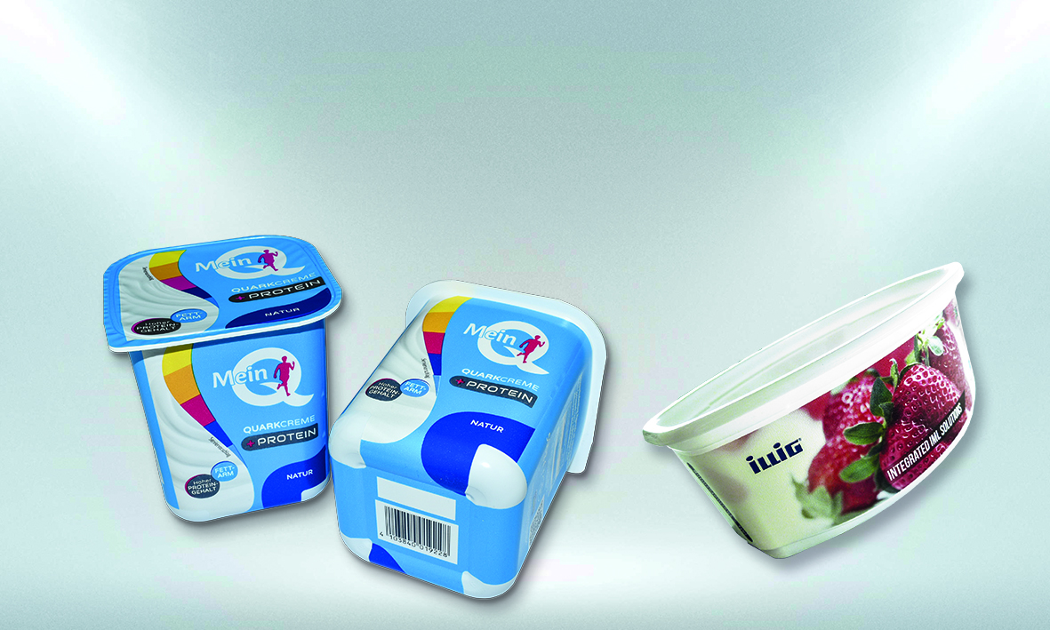

The FSL 48 form, fill and seal line with integrated IML-T station allows production of thermoformed packs with brilliant decoration and ready for sale at the POS.

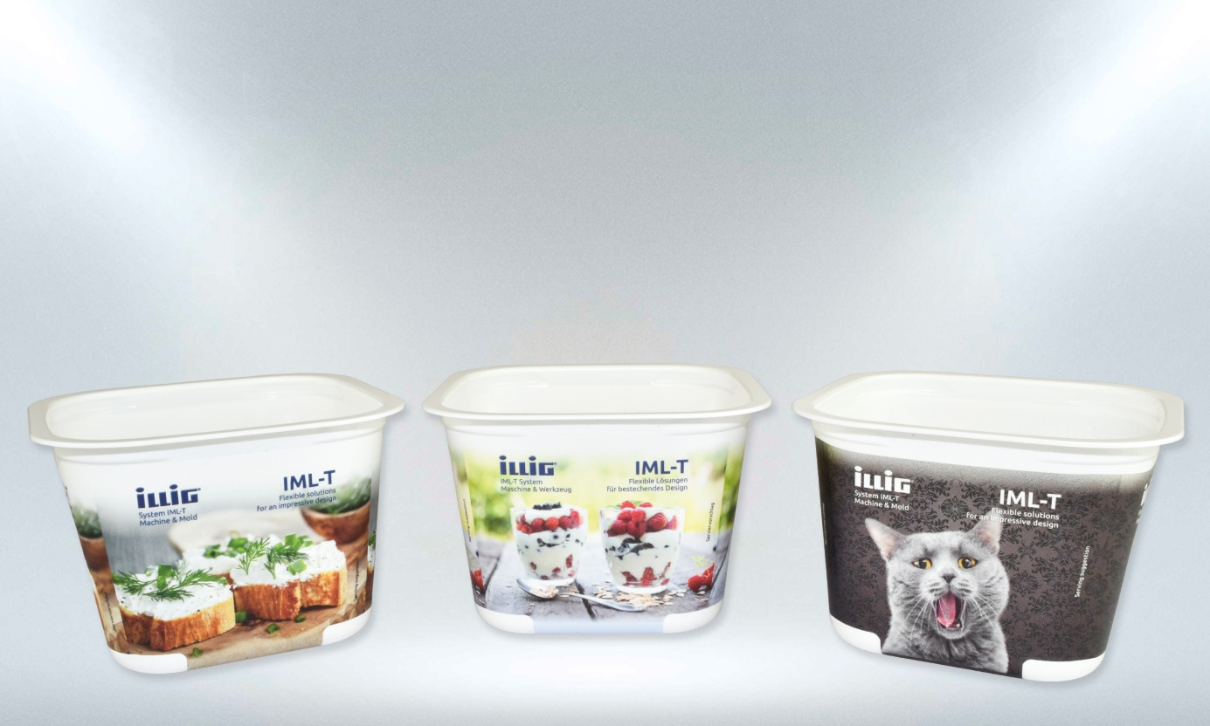

At the Interpack fair the 18-up mold employed will manufacture rectangular PP cups with three different decorations for the applications fresh cheese, fruit quark and pet food.
Pictures: ILLIG

