Plastic Recycling:
Shredding and washing technology specialist Lindner sets up U.S. subsidiary
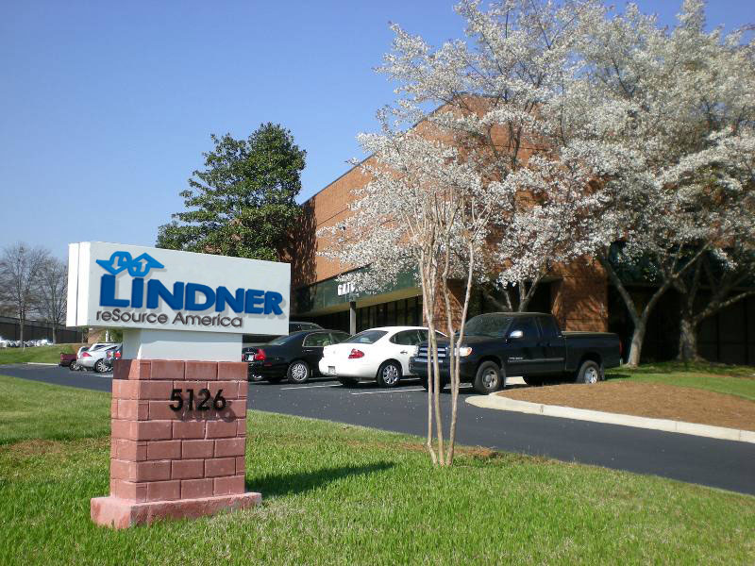
Großbottwar/Germany and Atlanta/GA, February 2015 -- Lindner reSource GmbH, a leader in the field of shredding technology for the plastics industry, is now represented in North America by its own subsidiary. Lindner Resource America LP of Atlanta, GA, will handle sales and technical service for the Linder Group's complete portfolio, which covers all processing equipment upstream of the actual extruder for plastic recycling operations. Included in this range are a wide selection of single-shaft shredders and granulators, high-performance washing systems for the thorough cleaning of post-consumer plastics (even highly contaminated grades), as well as the associated conveyor technology. One feature common to all systems is their proven ruggedness and longevity. A special strength of Lindner Resource America is their ability to tailor complete plants to customer-specific requirements.
Managing Director Harald Hoffmann comments: “With our new U.S. presence we shall be able to deliver perfect on-site support, carried out by our own technicians, to our North American customers. In addition, our new Technical Center in Atlanta is available for extensive customer trials.”
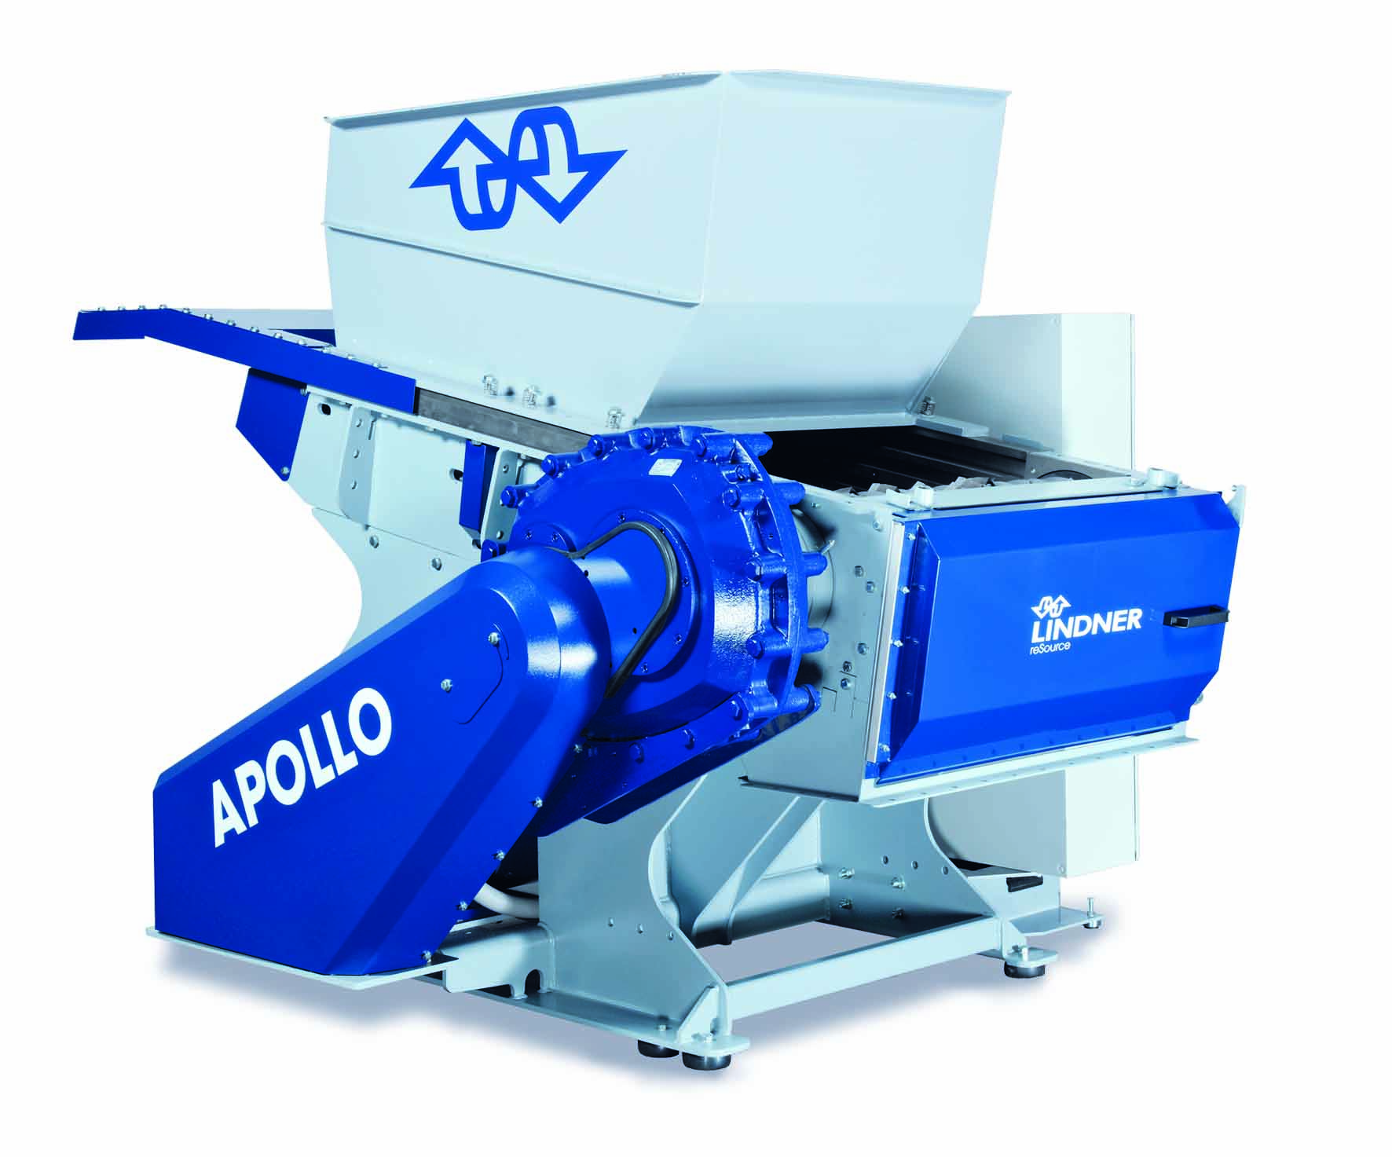
At NPE 2015 in Orlando, booth S26189, Lindner Resource America will be premiering its Apollo line of shredders for throughputs from 300 to 1500 kg/h. These systems are equipped with a newly developed movable hopper which facilitates rapid cleaning of the machine while also providing optimum access for maintenance. Furthermore, the Lindner Group will be showcasing a shredder from its Antares line plus their latest developments in the field of plastic washing equipment.
The Lindner Group headquartered at Spittal/Austria was established in 1948 as a mechanical engineering and equipment construction company and has evolved into a competent supplier of shredding technology for industrial applications. Employing around 300 people, the Lindner Group specializes in the development, manufacture and sales of complete lines and machines for producing alternative fuels. Lindner reSource GmbH, based in Germany, represents the Group's plastic and recycling activities and supplies high-powered single-shaft shredders with throughputs from 300 to 10,000 kg/h to industrial customers. Lindner washTech GmbH produces complete washing systems as a basis for efficient, high-quality recycling.

Further information:

Harald Hoffmann, Managing Director, LINDNER reSource GmbH
Häldenfeld 4, D-71723 Großbottwar / Germany
Phone: +49 (0) 71 48/16 05 38-0
E-mail: info@lindner-resource.com
www.lindner-resource.com
Tomas Kepka, Sales Director, LINDNER reSource America LP
5126 South Royal Atlanta Drive, Tucker, GA 30084
Phone: +1 7703496319
E-mail: info@lindner-resource.us
www.lindner-resource.us
Editorial contact and voucher copies:
Dr. Jörg Wolters, Konsens PR GmbH & Co. KG
Hans-Kudlich-Straße 25, D-64823 Groß-Umstadt / Germany
Phone: +49 (0) 60 78/93 63-0
E-mail: joerg.wolters@konsens.de
www.konsens.de
The German and English text of this press release in *.doc format, as
well as the illustrations in print-quality resolution, are available for download at:
http://www.konsens.de/lindner-resource.html

