Micromat Plus 2000 from Lindner reSource:
Lindner shredder boosts efficiency in the production of high-grade recycled materials
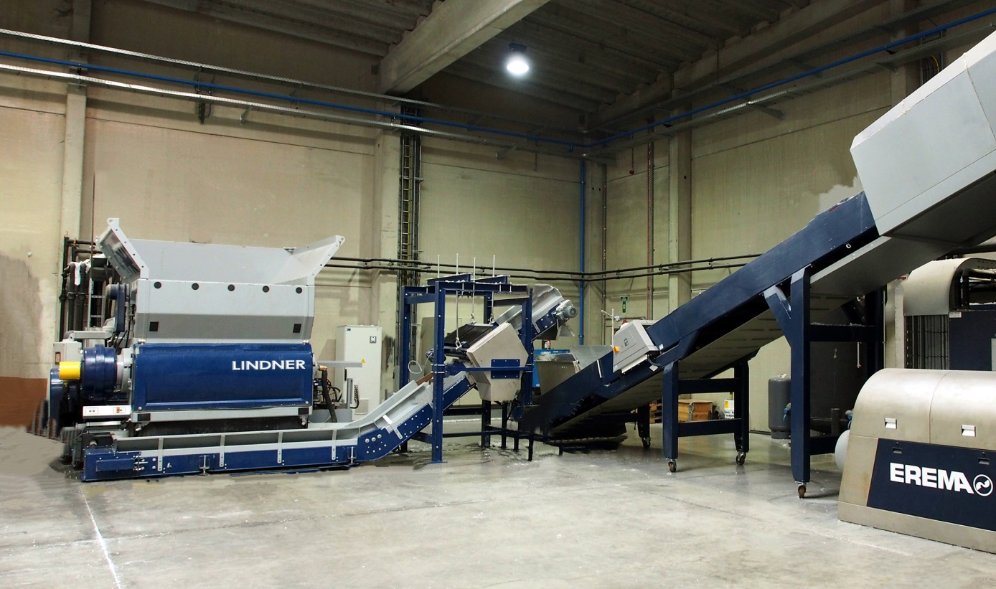
Micromat Plus 2000 and Erema’s INTAREMA® 1714 TVEplus® working together at Tivaco: Lindner’s high-performance shredder prepares the starting materials so as to boost the throughput capacity of the downstream extrusion process by up to 15% in comparison with direct processing.

Großbottwar/Germany, April 2016
Belgian plastics recycler Tivaco is converting clean post-industrial scrap into high-grade pellets for demanding applications. On its latest, fully automated line the company uses cutting-edge Austrian/German technology to provide recyclates of highest possible quality at throughputs of up to 1,700 kg/h. Cornerstones of this line are a Micromat Plus 2000 shredder from Lindner reSource (www.lindner-resource.com) and a downstream INTAREMA® 1714 TVEplus® recycling/extrusion line from EREMA (www.erema.at). The shredder, which is precisely tailored to the capacity of this extruder, shreds filaments, tapes (raffia), Big Bags or nonwoven fabrics made of polyolefins (PE, PP) to the ideal size for processing in the extruder. Using this preshredding process means that Tivaco has been able to increase the throughput capacity of the INTAREMA system by up to 15% in comparison with direct processing of the unprocessed material.

Thanks to its capacious hopper, the shredder can be charged with batches of up to 2 tonnes of material by forklift truck/tipper and acts, so to speak, as the stockpile for the extruder. A precision controller and numerous programs for a wide variety of different materials mean that the shredder can be set so that it always supplies the extruder with exactly the quantity of shredded material which, depending on the nature of the material, the extruder can handle. Any metals exposed by the shredding process can be detected and separated by means of a metal detector and magnet. The Micromat Plus thus ensures that the feed material is also ideal in terms of purity and dimensions for the downstream extrusion process. Moreover, there is no longer any need for laborious and costly manual charging of the recycling line.

The Micromat Plus 2000 is one of Lindner reSource's comprehensive range of shredders for the plastics industry. The Micromat series has a wide variety of drive systems, rotors and blades that can be freely combined with one another. This means that the shredder can be adapted to a particularly wide range of materials, so increasing productivity. The configuration devised for Tivaco is optimised for problematic materials such as Big Bags, filaments or stretch films. The shredder is equipped with a 160 kW motor which is designed for high throughput and small grain sizes using a clean starting material. Further components include special screens and a point blade rotor with a length of 2,000 mm and a diameter of 563 mm which is fitted with 43 × 43 mm blades, four sides of which can be used, to ensure precise cutting and a high throughput.

As Thibaut Debode, Tivaco's Chief Executive, Purchasing & Sales explains: "Since price pressures are severe, even high-grade recycled products can only be produced economically viably by keeping consumption of resources low and ensuring a high level of automation and extended periods of uninterrupted production. The Micromat Plus 2000 from Lindner reSource has helped us to achieve these goals. The drive for this shredder is particularly economical in energy terms, while the high quality of all the components ensures a long service life. If, despite being highly wear-resistant, the blades have to be rotated or replaced, these tasks can be carried out quickly thanks to the easy access provided by the large hydraulic maintenance hatch. Other factors which led us to decide on this system were the well-tried collaboration between Lindner and EREMA and Lindner's across-the-board support from the design stage, during optimisation of the machine to our requirements and then during ongoing production. The line has operated without a hitch since it was commissioned in mid-2015 ."

The line described here can been seen in operation at www.youtube.com/watch?v=RFrHuzeSZ2k.
Tivaco, based in Blandain (Belgium), has four recycling lines with a total capacity of around 20,000 tonnes/year stated in terms of pellet output. The standard product range extends from polypropylene (PP), polyethylene (PE), polystyrene (PS), plasticised PVC and thermoplastic elastomers (TPE), such as SBS, SEBS, EVA, TPU, etc., up to custom-optimised compounds for applications in the automotive or construction industries, in agriculture and in the production of household goods etc..

The Lindner Group, headquartered in Spittal (Austria), was established in 1948 as a mechanical engineering and equipment construction company and has evolved into a prominent manufacturer of shredding technology for industrial applications. Employing around 300 people, the Lindner Group specialises in the development, manufacture and sale of complete lines and machines for producing alternative fuels.
Lindner’s sales and customer support company Lindner reSource GmbH, based in Großbottwar (Germany), represents the Group's plastics and recycling activities. The company supplies industrial customers with high-power single-shaft shredders with throughputs from 300 to 10,000 kg/h.

Further information:

Harald Hoffmann, Managing Director, LINDNER reSource GmbH
Häldenfeld 4, D-71723 Großbottwar
Tel. +49 (0) 71 48/16 05 38-0, Email: info@lindner-resource.com

Editorial contact and voucher copies:
Dr. Jörg Wolters, Konsens PR GmbH & Co. KG
Hans-Kudlich-Straße 25, D-64823 Groß-Umstadt
Tel.: +49 (0) 60 78/93 63-0, Email: joerg.wolters@konsens.de

This press release in German and English (.doc file) and the
images in print-ready resolution can be downloaded from:
http://www.konsens.de/lindner-resource.html

