Lindner at K 2016
New Micromat WS wet shredder optimises processing in modern plastics washing systems

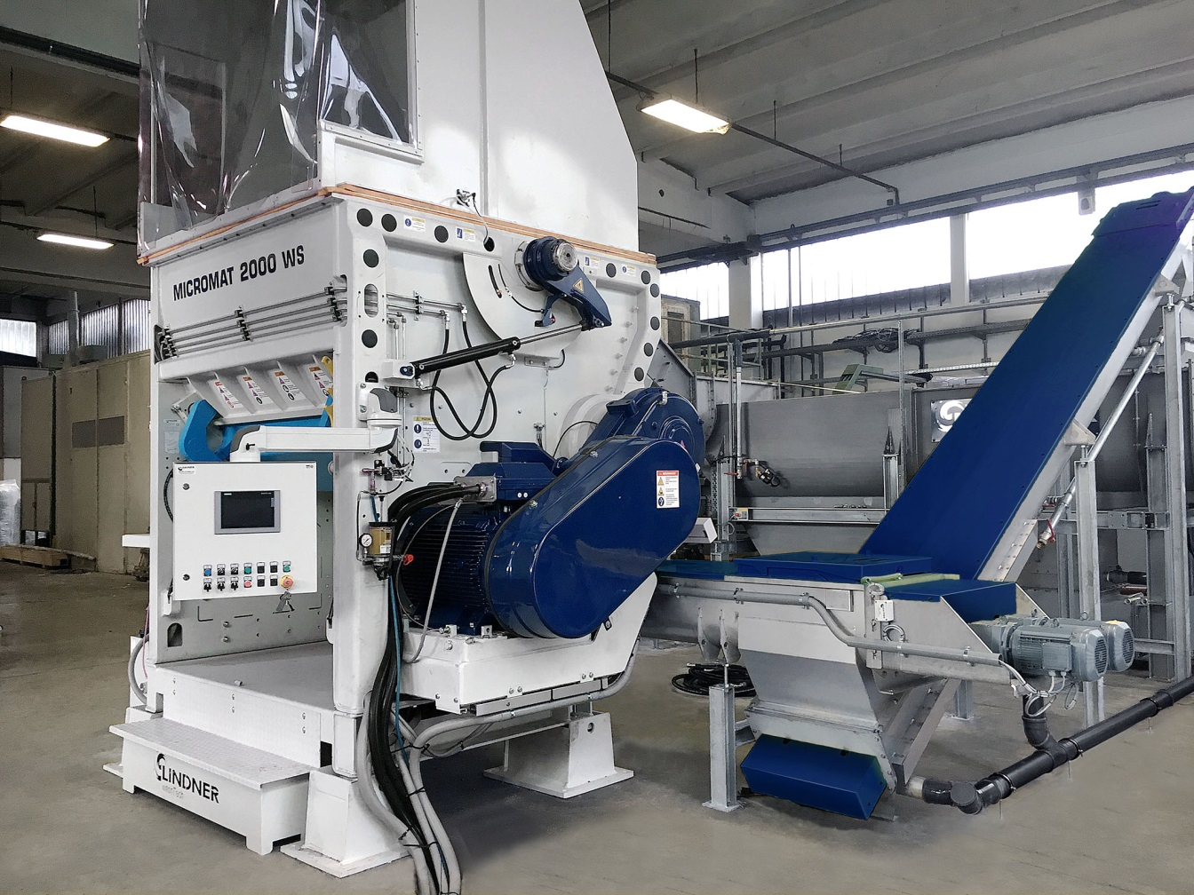
Used as a pre-shredder, the new Lindner Micromat WS wet shredder is the first step in washing systems for post-consumer plastic scrap. Together with another two new downstream systems, the Rafter Pre-washer and the Loop Dryer, it is part of the innovative plastics shredding and washing system solution which the Lindner Group from Austria will be premiering at K 2016. © Lindner Recyclingtech
Großbottwar, Germany, October 2016
Lindner's Micromat WS wet shredder is a new addition to its successful Micromat series and is specially designed for pre-shredding contaminated post-consumer plastic scrap, such as lightweight packaging, bottles or films. By directing a jet of water onto the rotor, the friction arising during the shredding process can be used to detach dirt particles. This means that the material undergoes pre-cleaning from the outset, which has a positive impact on downstream processing. The water used simultaneously ensures uniform and controlled material discharge.
Once the material has passed through the pre-shredder, screw conveyors deliver it, so ensuring it remains in permanent contact with water, directly to the Rafter pre-washer, itself a newly developed product. The Rafter easily, gently and thoroughly detaches and separates contamination and adhering paper from the plastic. The new Micromat WS, together with the Rafter and the Loop Dryer, another new product, forms an innovative, new generation of compact and economic plastics shredding and washing systems from Lindner which will be premiered at K 2016.
Depending on size, the Micromat WS has a nominal throughput capacity of 1,500 to 2,500 kg/h (WS 1500), 2,000 to 3,000 kg/h (WS 2000) and 2,500 to 3,500 kg/h (WS 2500). This new pre-shredder is thus perfectly suited to the typical capacities of today's plastics washing systems and so helps to ensure continuous in-line processing of post-consumer scrap right up to the finished recycled pellets or recycled film.
The WS series in particular features a fully watertight design with special rotor seals which seal the cutting chamber off from the outside. Depending on the degree of contamination, six to eight integrated nozzles spray between 2 and 30 m³ of water per hour directly onto the rotor, the speed of which can be controlled by a frequency converter. Lindner has also adapted the blade distribution on the rotor and the counter-blade zone to the specific conditions which apply to shredding with exposure to water and has optimised material flow to the screen. Like all machines in the Micromat series, the WS models are supplied with an adjustable slip clutch which, unlike in high-speed wet chopping mills, miminises the risk of damage due to foreign matter.
As Harald Hoffmann, Sales Director Plastics Devision of Lindner Recyclingtech, explains: "Lindner's single-shaft Micromat shredders have in recent years successfully demonstrated their reliability as pre-shredders for films and rigid plastics. They produce a uniform shredded product, so helping to ensure trouble-free operation of downstream washing systems, while their large foreign matter flap which optimises access for maintenance and their low operating costs are further convincing arguments in their favour. Lindner's combination of Micromat WS, Rafter and Loop Dryer breaks new ground in post-consumer plastic scrap shredding and washing, helping recycling plant operators to boost efficiency, reduce wear and tear on downstream processing systems and so operate still more economically."

Lindner, Spittal an der Drau/Austria (www.l-rt.com) has, for decades now, been offering innovative and successful shredding solutions, from the original planning, development and design to the production and after-sales service. Everything is supplied from a single source. At its production centers in Spittal/Drau and Feistritz/Drau, Lindner manufactures machines and plant components that are exported to nearly one hundred countries around the world. Its portfolio includes not only stationary and mobile crushing and shredding machines for waste recycling, but also complete systems for plastics recycling and the processing of substitute fuels and substrates for biomass equipment.
Lindner’s subsidiary in Großbottwar (Germany) represents the Group's plastics and recycling activities, supplying high-power single-shaft shredders with throughputs from 300 to 10,000 kg/h.

Further information:

Harald Hoffmann, Sales Director Plastics Devision of Lindner Recyclingtech
Häldenfeld 4, D-71723 Großbottwar
Tel. +49 (0) 71 48/16 05 38-0, Email: info@lindner-resource.com

Editorial contact:
Mag. Veneta Buchegger, PR & Marketing
Lindner-Recyclingtech GmbH
Villacher Straße 48, A-9800 Spittal an der Drau
Tel.: +43 4762 2742-729, Fax: +43 4762 2742-9032
E-Mail: Veneta.Buchegger@l-rt.com

This press release in German and English (.doc file) and the
images in print-ready resolution can be downloaded from:
http://www.konsens.de/lindner-resource.html

