motan innovation award 2016:
four top ideas nominated
The motan innovation award will be made for the first time at K 2016 in Düsseldorf. The jury has nominated four innovative developments and solutions in the materials handling area as candidates for the award.

“The future is derived from ideas. motan honours the best of them”. With this slogan, motan holding announced the motan innovation award for the first time in 2015. The prize award ceremony takes place on 21 October 2016 during the K fair in Düsseldorf. Among the numerous submissions, the jury has filtered out the four particularly innovative and original ideas and nominated them for the prize award.
Dry doser – multiple use of energy for drying and dosing
For many applications, hygroscopic plastics have to be dried before processing. The idea aims at using energy a number of times in both dosing and drying areas and to thereby significantly reduce overall energy consumption. Work can also be made more ergonomic this way.
Matrix coupler – automatic material distribution station for small conveyor lines
Conventional material distribution stations require manual reconnection of hoses leading to the conveying equipment when changing material. The matrix coupler automates material distribution by means of a new multiple separator design. This is how contamination in neighbouring lines is prevented. This is a practical, cost-effective and novel approach.
Octa-Flow-Bag – emptying of residual material in Octabins benefits the environment
Octabins are widely used as packaging to deliver plastic granulates. They are mostly emptied during production by means of an automatic conveyor line. Residual material often remains however in the corners and has to be manually removed by vacuuming. A new development involves automatically taking these residual amounts of material to the centre of the Octabin, from where they can be easily removed.
Inductive heating - energy transfer by radiation
Pre-heated air flowing through plastic granulates removes humidity from the material. A novel means of automatic drying is based on inductive transfer of energy by radiation. This is highly efficient and can be precisely controlled - these are the advantages resulting from an idea that was born while seeking a dew point sensor solution.
The jury
The best innovation is decided by an independent jury of renowned experts, who possess immense theoretical and practical knowledge in plastics production and processing.
- Prof. Dr. Martin Bastian has been managing SKZ in Würzburg, the largest plastics institute in Germany, since 2006 as Institute Director.
- Prof. Dr.-Ing. Carsten Manz has been President since 2014 of Konstanz University for Technology, Industry and Design.
- Dr.-Ing. Peter Faatz has been a Professor for plastics technology and has been managing since 2005 the plastics technology process development activities at INA Schaeffler.
- Karl Miller started in 1987 as Technical Sales Engineer at Colortronic and manages today motan-colortronic Ltd in the United Kingdom.
Details about the innovations will be presented during the K. The mia 2016 winner, selected from among the above mentioned nominations, will also be presented then during a special event on the motan-colortronic stand
motan-colortronic at K 2016: Hall 9, Stand C64

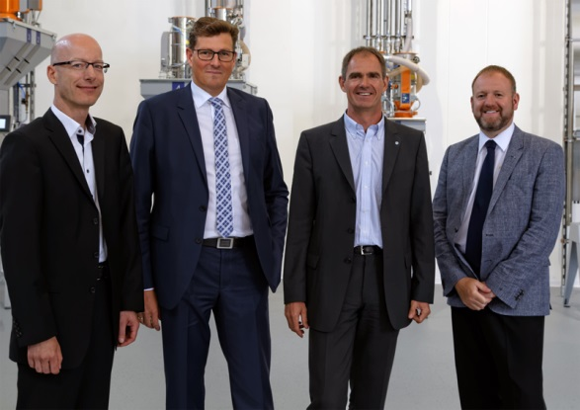
((mia Jury 2016.jpg)) The present jury (from left to right): Dr.-Ing. Peter Faatz, Prof. Dr.-Ing. Carsten Manz, Prof. Dr. Martin Bastian, Karl Miller (Photo: motan)

The motan group
The motan group headquartered in Constance, Germany, on Lake Constance was founded in 1947. As leading provider for sustainable raw material handling, they operate in the areas injection moulding, blow moulding, extrusion and compounding. Innovative, modular system solutions for storage, drying and crystallisation, conveying, dosing and mixing of raw materials for the plastics manufacturing and processing industries are part of the application orientated product range.
Production takes place at different production sites in Germany, India, and China. motan distribute their products, system solutions, and services via their motan-colortronic regional sales centres. With currently over 450 employees the company has a yearly turnover of roughly 110 million Euros. Because of their network and long-standing experience, motan can offer their customers what they really need: individually tailored solutions with real added value.

Contact:
motan holding ag
Carl Litherland
Stromeyersdorfstr. 12
78467 Konstanz / Deutschland

Tel. +49 7531 8178 15
carl.litherland@motan.com
www.motan.com

