Materials handling – advanced innovations to be distinguished during K‘2016

motan innovation award “mia” awarded
The excited waiting has come to an end: On the 21st October 2016, motan announced and honoured the winners of the competition mia – motan innovation award 2016 – which began roughly 10 months ago.
A top-class jury evaluated in advance the nominated solutions intensively and detailed in regards to level of innovation, relevance for practical application in the plastics industry, and technical feasibility and market potential within materials handling. Instead of the usual three, four innovations for different functions of material logistics and handling have made it onto the podium: Along with first and second place, the jury awarded two third places. Prize money of over 20.000 euro was donated by motan holding gmbh.
1st place: Ludwig Reissner
With the Matrixkoppler, an automated material station for small conveying systems, Ludwig Reissner has made material changes even more efficient and safe. Conventional material stations require manual switching of the hoses leading to the material loaders during material changes. The Matrixkoppler automated the material allocation with a newly designed multiple switch. This way, contamination from neighbouring lines can be prevented. This is practical, cheap, and completely new.
motan is honouring this development with prize money of 10.000 euro.
2nd place: Team Fabian Kienzler
Together with Arnulf Hörtnagl, Marc Hiefer, and Oscar Lattner, Fabian Kienzler has developed an alternative method for drying of granules. At the core of the innovation is the use of an inductive heating element – for energy transfer via radiation. Here, pre-warmed air flows through the granules to extract moisture. This new automated drying is efficient and can be controlled precisely. The idea was born while searching for a dew point sensor.
motan is honouring this development with prize money of 5.000 euro.
3rd place: Peter Haupt
Energy which is used for drying and dosing in usual material flow constellations, is used more than once by the dry dosing unit developed by Peter Haupt. The idea is focussed on dramatically reducing energy consumption – and therefore costs. Operation can then also be designed more ergonomically.
motan is honouring this development with prize money of 2.500 euro.
3rd place: Karl Wolfgang
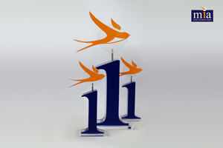
Better utilisation of material and increased cleanliness are the benefits of using the Octa-Flow-Bag by Karl Wolfgang. If octabins are emptied with an automated conveying system in production, then material normally remains in the corners and must be sucked out manually. This new development transports remaining material automatically into the middle of the octabin, where it can be removed easily.
motan is honouring this development with prize money of 2.500 euro.

The prizes were awarded by Sandra Füllsack, CEO of motan holding gmbh, as well as the four jury members. The submissions for the next mia 2018 awards will start in January 2017 and the prize giving ceremony will take place in two years’ time at the Fakuma exhibition in October 2018 in Friedrichshafen.

((mia_Pokal 2016.jpg)) Trophy of the innovation award “mia” 2016 (image: motan)

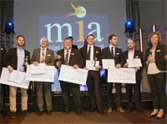
((mia_Gwinner.jpg)) Very happy winners of the innovation award “mia” 2016 onstage at K 2016 with motan-CEO Sandra Füllsack, (image: motan)

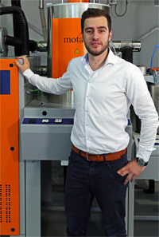
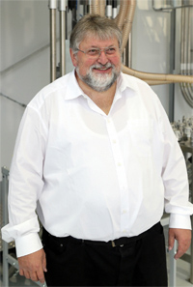
((mia_Ludwig-Reissner.jpg)) 1st place for Ludwig Reissner and his “Matrixkoppler”. (image: motan)

((mia_Fabian-Kinzler.jpg)) 2nd place for Fabian Kienzler and his team for their idea for an alternative drying of granules. (image: motan)

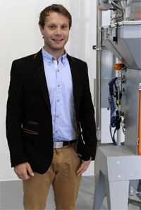
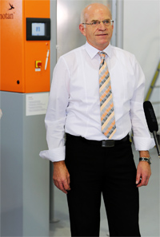
((mia_Peter-Haupt.jpg)) 3rd place for Peter Haupt and his idea for energy saving drying and dosing technology. (image: motan)

((mia_Karl-Wolfgang.jpg)) 3rd place for Karl Wolfgang, who solved the problem of emptying octabins with his Octa-Flow-Bag. (image: motan)

The jury
The independent jury chosen to decide the best innovation is made up of experts who possess immense theoretical and practical knowledge in plastics production and processing.
- Prof. Dr. Martin Bastian has been the institution director of SKZ in Würzburg, the largest plastics institution in Germany, since 2006.
- Prof. Dr.-Ing. Carsten Manz has been president of the Hochschule Konstanz for applied sciences since 2014.
- Dr.-Ing. Peter Faatz has been head of process development for plastic technology at INA Werks Schaeffler since 2005.
- Karl Miller started 1987 as a Technical Sales Engineer at colortronic and today is head of motan-colortronic Ltd. In Great Britain.
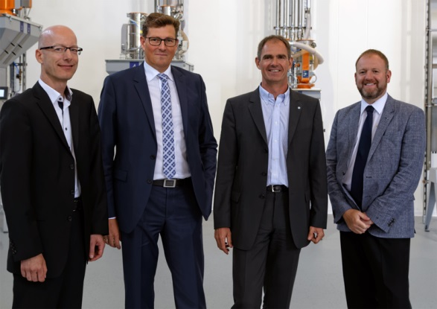
((mia Jury 2016.jpg)) The current mia jury (f.l.) Dr.-Ing. Peter Faatz,
Prof. Dr.-Ing. Carsten Manz, Prof. Dr. Martin Bastian, Karl Miller (image: motan)

The motan group
The motan group based in Constance on Lake Constance was founded in 1947. As leading provider for sustainable raw material handling, they operate in the areas injection moulding, blow moulding, extrusion, and compounding. Innovative, modular system solutions for storage, drying and crystallisation, conveying, dosing, and mixing of raw materials for the plastics manufacturing and processing industries are part of the application orientated product range.
Production takes place at different production sites in Germany, India, and China. motan-colortronic distribute their products, system solutions, and service via their regional centres. With over 450 employees currently, a yearly turnover of roughly 110 million euros is achieved. motan is active in sales and service in over 120 countries. Because of their network and long-standing experience, motan can offer their customers what they really need: individually tailored solutions with real added value.
Contact:
Motan holding gmbh
Stromeyersdorfstr. 12
78467 Konstanz / Germany

Tel: +49 7562 76 100
Mobile: +49 151 230 60860

carola.wirth@motan.com
www.motan-colortronic.com

