ProTec Polymer Processing at Chinaplas 2017
Launch of five-strand laboratory LFT lines for end users

Bensheim, March 2017 – ProTec Polymer Processing will launch five-strand laboratory LFT lines for developing high quality long-fibre-reinforced thermoplastics by pultrusion at this year's Chinaplas from 16 to 19 May 2017 in Guangzhou. These Industry 4.0 capable lines with complete materials handling capabilities are equipped with the new user-friendly SOMOS® control/excellence controller. Such laboratory lines allow LFT compound manufacturers to be more responsive by permitting on-site development, testing and reliable scaling up of their formulations, so minimising downtime.
From lab to production
An investment in the future, the laboratory lines allow LFT compounders to be more flexible and independent. By developing their own formulations in-house in parallel with ongoing production, line users can respond more rapidly to market requirements.
The laboratory lines have a narrower die width and are designed to handle five glass fibre or three carbon fibre strands. Otherwise, the design of the modules and their complete integration with materials handling components are the same as in ProTec's conventional pultrusion lines. A keystone of the line is a high-performance underfed compounding extruder equipped with a SOMOS® Gramix S gravimetric dosing system capable of accurately dosing and mixing up to seven components. As a result, a very wide range of individual formulations of the polymer matrix can be produced very flexibly directly in the process.
The new user-friendly Industry 4.0 capable SOMOS® control/excellence controller means all modules can simply be selected centrally via a touch screen operator console: line speed, throughput of the underfed extruder and pellet chopping length can all be varied. SOMOS® systems for drying, conveying, dosing and mixing the various material components are also integrated into the line controller. USB and SD ports mean that up to 1,000 custom formulations can be saved and reliably transferred to production. Because SOMOS® controllers are used for both the laboratory and the production lines, production parameters can be straightforwardly transferred, so minimising downtime due to product changeovers. With their remote control function and internet access, the lines can be remotely serviced, optionally also via a WLAN hotspot.
Versatile technology for high quality LFT compounds
ProTec's LFT technology is suitable for producing a wide range of materials comprising variable fibre reinforcement in a defined pellet length and using different polymers as the matrix. The lines are capable of producing LFT pellets with fibre contents of up to 65 wt.% at throughputs of up to 1,000 kg/h. Any conventional thermoplastics, including biopolymers such as PLA (polylactic acid), may be used as the matrix. Recycled material and additional fillers may likewise be included in the material formulation. Glass, steel, carbon or aramid fibres can be used for reinforcement. Even the extremely difficult pairing of carbon fibres with PP can be reliably processed. In practice, LFT materials with fibre lengths of 7 mm to 15 mm are conventional. When injection moulded, LFT compounds with fibre reinforcement along the length of the pellets result in components which combine high strength and light weight with very good surface quality, as is most particularly required in the automotive industry.
ProTec Polymer Processing GmbH based in Bensheim, Germany, has been a recognised partner to plastics processing and manufacturing companies for many years. Its service portfolio includes systems for the efficient handling of plastic materials, turn-key systems for solid-state post-condensation of plastics, recycling lines as well as complete systems for producing long-fibre reinforced thermoplastics (LFT pultrusion lines). As a member of the Schoeller Group, ProTec Polymer Processing has access to a global sales and service network and has the ideal infrastructure in place to provide comprehensive on-site customer support.
■■■

Subsidiary in Shanghai, China:

ProTec Polymer Processing (Shanghai) Co. Ltd.

Mr. Peng Fei

Room 1501, No. 138 Pingxingguan Road, Shanghai, 20070, China

Tel.: +86 21 6132-6371, Email: f.peng@sp-protec.com.cn

Further information:
Kirsten Hennige, Marketing Manager
ProTec Polymer Processing GmbH, Bensheim Headquarters, Stubenwald-Allee 9, D-64625 Bensheim
Tel.: +49 6251 77061-150, Fax: -81 150, Email: kirsten.hennige@sp-protec.com

Editorial contact and voucher copies:
Georg Sposny, Konsens PR GmbH & Co. KG,
Hans-Kudlich-Straße 25, D-64823 Groß-Umstadt – www.konsens.de
Tel.: +49 6078 9363-15, Fax: -20, Email: georg.sposny@konsens.de

Dear colleagues,
Press releases from ProTec Polymer Processing
including text and images in print-ready resolution can be downloaded from:
www.konsens.de/protec.html

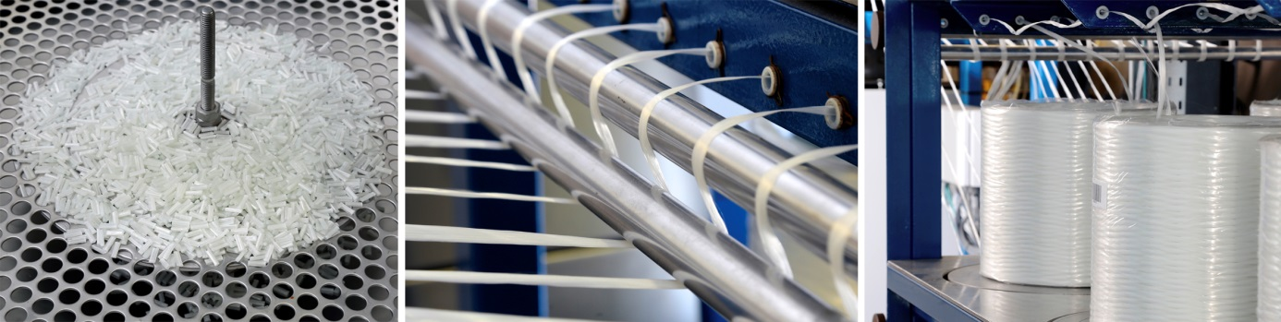

ProTec's LFT pultrusion technology produces high quality long-fibre-reinforced pellets with a wide range of polymer matrices and huge variety of reinforcing fibres. This technology also permits reliable and flexible adjustment of matrix properties.

Photo: ProTec Polymer Processing

