ERIKA avoids damage to robot dress packs
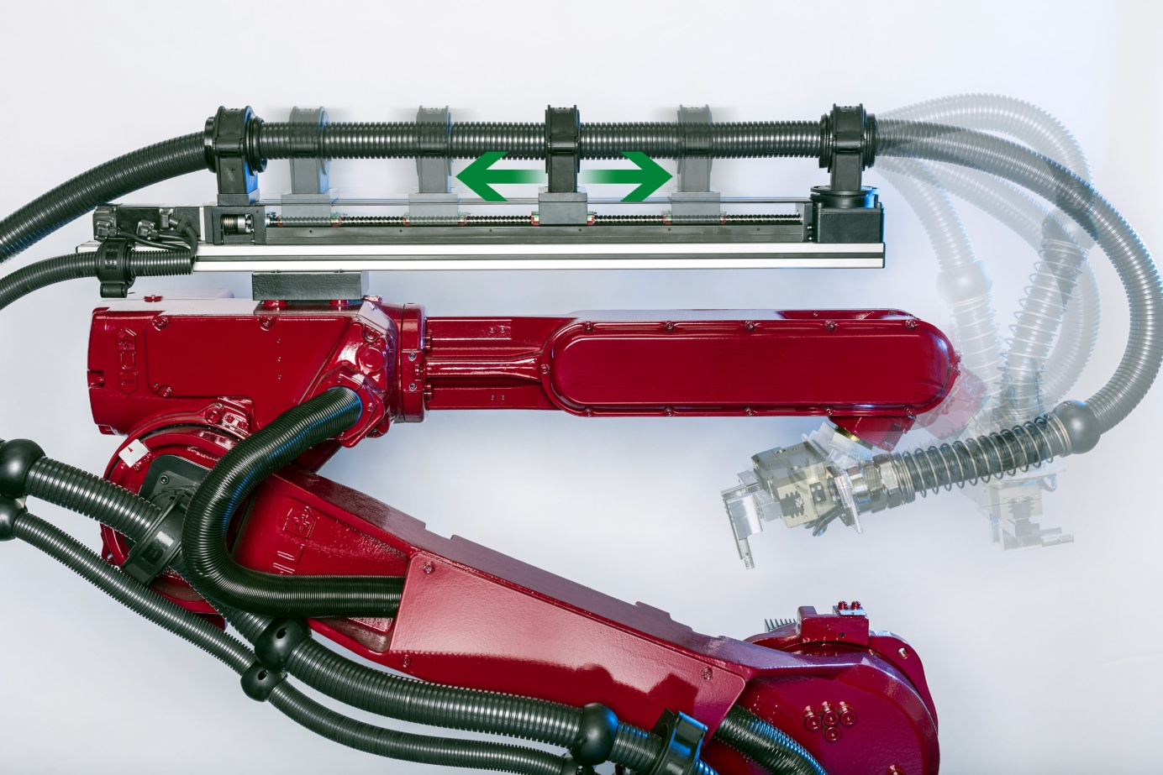

ERIKA moves cable protection systems automatically in sync with each operation of the robot arm. It thus eliminates the potentially high mechanical loads which act on the dress pack in conventional spring-loaded length compensation systems, enabling the user to save on maintenance and, in many cases, to avoid high follow-up costs.

Wiehl-Bomig / Germany, June 2014. The new ERIKA active length compensation system unveiled by REIKU significantly reduces the high mechanical loads acting on dress packs during the fast and continuing dynamic movement of robot arms. ERIKA achieves this by moving the pack along a linear guide track in synchronism with the robot's functions, thus balancing out the difference between the maximum cable length and the actual length required at any given time. This method results in substantially reduced material wear when compared with conventional trailing-type systems in which the excess cable is retracted via spring forces which act directly on the dress pack and increase with the amount of spring travel. Accordingly, ERIKA reduces the risk of damage to the dress pack and its content, i.e., cables as well as pneumatic and fluid-carrying hoses. The service life of these systems can thus be extended significantly, and costly down times can be minimized. REIKU's new automatic length compensation system will be globally premiered at AUTOMATICA 2014, Stand 409 / Hall A4.

ERIKA is available as an accessory for new robot systems or as an add-on retrofit module for corrugated tubing in the 29 to 70 mm nominal width range. Depending on the application, it may be configured for between 0.5 m and 1 m of operating travel, attaining traversing speeds of up to 2 m/s. The controller keeping ERIKA in sync with the robot is a straightforward unit relying on defined trigger signals which are transmitted by the robot's control system as it executes its sequential program. As a result, ERIKA can be integrated into existing installations without requiring any extensive programming.

The ERIKA system (patent pending) consists of five basic elements. The linear guide track with its electric motor and spindle drive is screwed firmly to the robot arm near the axis 4. The carriage moving parallel to the robot arm, carrying the REIKU gripping clamp and combination jaw, serves to hold the corrugated tube and to move it axially. The combination jaw allows two corrugated tubes of different type or profile to be joined together. At both ends of the linear unit, a REIKU gripping clamp with sliding jaws guides the corrugated tube. The clamp pointing in the direction of axis 6 is attached to a rotary flange which provides additional stress relief to the tubing under major deflection angles. The opposite clamp, on the loop side, can be optionally fitted with a REIKU spring to prevent kinking of the corrugated tube. For optimum all-round protection against aggressive ambient factors, REIKU also supplies optional bellows to enclose the linear unit.

Klaus-Peter Scholten, Project Manager at REIKU, comments: „Through our customers, we are very familiar with the issues relating to the indispensable length compensation for dress packs on industrial robots. These packs may be agile enough when it comes to, say, rotating through up to 400 deg. about axis 6 while bending in axis 5 at the same time, but as they are often moved against the force of a return spring, fatigue fractures and breakage in the attachment areas are common. These phenomena often result in cable damage which may paralyze entire production sectors.“

Scholten continues: „With ERIKA we have now developed a cost-efficient solution which helps to avoid such failures intelligently. ERIKA knows the current cable length requirement at any given time. Accordingly, the system provides just the amount of cable needed for the current movement of the robot tool. As less cable is demanded, it retracts the excess cable without having to act against the reactive spring forces formerly relied upon. In addition, ERIKA protects the loop from getting snagged on the workpiece or on the robot itself; it also prevents uncontrolled vibrations that might impair the robot's motion accuracy, and it makes sure the corrugated tube cannot get into hazard areas where it might be at risk from high temperatures or running machinery. The extra cost of an ERIKA system will usually be recovered with the first production breakdown that is successfully avoided.“

REIKU GmbH (www.reiku.de) is an internationally operating medium-sized company based in Wiehl / Germany which develops, produces and markets complete cable protection systems for static and dynamic uses in robotics and automation technology, in addition to bundling systems with a zipper style closure, plastic sheathing, corrugated tubing and fittings, heat protection tissues and braided tubings. The company's products are designed to protect cables, conductors and other parts from contamination with foreign matter as well as from chemical, thermal or mechanical loads. Its portfolio of cable protection systems made of advanced engineering plastics extends from fittings through bracket systems and tube clamps to sophisticated system components which comprise connecting joints and cable stars in addition to jointed tubing, gripping clamps, conduit protectors and spring holders.

Further information:
Klaus-Peter Scholten, REIKU GmbH Kabelschutzsysteme
Robert-Bosch-Straße 3, D-51674 Wiehl-Bomig / Germany
Phone: +49 (0) 22 61/70 01-0, Fax: +49 (0) 22 61 70 01-24
E-Mail: scholten@reiku.de
www.erika.reiku.com

Editorial contact and voucher copies:
Dr. Jörg Wolters, Konsens PR GmbH & Co. KG
Hans-Kudlich-Straße 25, D-64823 Groß-Umstadt / Germany
Phone: +49 (0) 60 78/93 63-0, Fax: -20
E-mail: joerg.wolters@konsens.de

This press release is available in German and English as a .doc file, along with the photo in printable resolution, for download at
www.konsens.de/reiku.html after June 3rd, 2014

