REIKU's bio-based corrugated cable protection tubing combines outstanding bending cycle resistance with environmental benefits
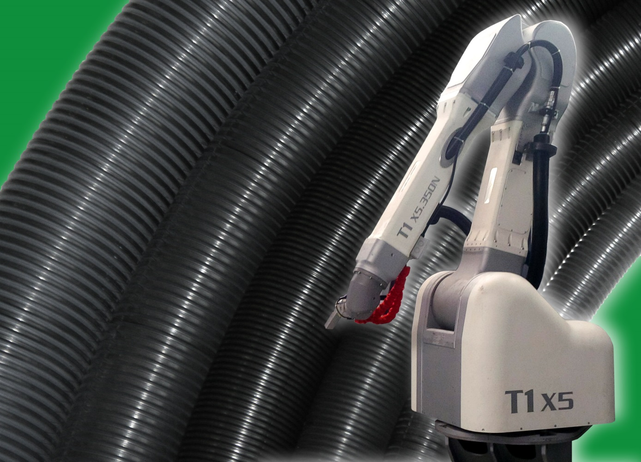
"Green" corrugated cable protection tubing from REIKU cannot not be recognized by its color. Like its counterparts made of oil-based materials, it is black or gray. Its big advantages become evident in robot operation with a continuous series of bending cycles, where the products have a significantly longer service life. One of the first users is b+m surface systems, a leading supplier of fully automated painting plants and paint application systems for surfaces with very high quality standards. Photo: REIKU
Wiehl, Germany, February 2015. REIKU’s corrugated cable protection tubing made from renewably sourced plastic is an environmentally friendly alternative to products made from conventional oil-based materials, and also offers tangible advantages in application. Under a continuous series of bending cycles, which is typical for many industrial robots, this product has the highest service life of all corrugated cable protection tubing in this manufacturer's extensive portfolio. Says Sales Manager Peter Sailer: "In internal trials, corrugated bio-based tubing with a nominal width of 70 mm remained free of damage even after 16 million cycles in the flexibility test, which corresponds in practice to a service life of around three years. With the development of this corrugated tubing product, REIKU has demonstrated that top-performance cable protection is ensured, also in view of dwindling oil reserves."
The outstanding behavior of this tubing under dynamic stress is down to the special properties of the material used to produce it: REIKU's corrugated cable protection tubing, which is available in nominal widths of 12 – 70 mm, is made of halogen-free flame-retardant polyamide 11 (PA11). This bio-based engineering plastic combines excellent mechanical properties under static and dynamic load with high temperature and chemical resistance. It is also abrasion-resistant. Because it is produced primarily on the basis of castor oil obtained from the seeds of the tropical castor oil plant – also called the miracle tree – it has a better CO₂ balance than polyamides based on fossil energy sources.
One of the first users is a German company called b+m surface systems, a leading supplier of fully automated painting plants and paint application systems for surfaces with very high quality standards. The company uses the resource-conserving bio-based corrugated tubing from REIKU as standard for its latest painting robot generation, Type T1 X5. The tubing is mounted on the outside of the robot arm, ends on its third axis, and protects the cable and wiring packages that supply the head of the robot and its atomizers with control signals, energy, air, coating material and rinse media.
The 6-axis jointed-arm robots from b+m surface systems normally operate in three-shift rotas and continuously perform fast, three-dimensional movements with high axis speeds and accelerations. To achieve a long service life for all the relevant components, the cable protection system must be able to withstand these extreme stresses. For this reason, the robot manufacturer has opted for REIKU's corrugated bio-based tubing, which is optimized for such high dynamic loads. After now more than 12 months of continuous industrial application, b+m’s experience has been nothing but positive. Over this period, the company has installed around 1,000 m of corrugated bio-based cable protection tubing NW70 and has so far not had a single report of failure or a single complaint. "For our customers, this means minimum downtimes due to maintenance work, and thus lower overall costs," says b+m.
REIKU corrugated cable protection tubing is available in a variety of types to satisfy specific application requirements. PA6 and thermoplastic polyester (TPE) are the materials of choice for general machine, apparatus and vehicle construction. Corrugated tubing of thermoplastic polyurethane (TPU) will also resist the high dynamic stresses that are typical for the movements of industrial robots. PA12 additionally complies with the demand in rough environments for high static and dynamic load stress resistance at particularly low temperatures, while the PA11 bio-based types combine a maximum of dynamic load resistance, UV, chemical and temperature resistance.
REIKU GmbH (www.reiku.de) is an internationally operating medium-sized company based in Wiehl / Germany which develops, produces and markets complete cable protection systems for static and dynamic uses in robotics and automation technology, in addition to bundling systems with a zipper style closure, plastic sheathing, corrugated tubing and fittings, heat protection tissues and braided tubings. The company's products are designed to protect cables, conductors and other parts from contamination with foreign matter as well as from chemical, thermal or mechanical loads. Its portfolio of cable protection systems made of advanced engineering plastics extends from fittings through bracket systems and tube clamps to sophisticated system components which comprise connecting joints and cable stars in addition to jointed tubing, gripping clamps, conduit protectors and spring holders.

Further information on cable protection systems:
Peter Sailer, REIKU GmbH Kabelschutzsysteme
Robert-Bosch-Straße 3, D-51674 Wiehl-Bomig / Germany
Phone: +49 (0) 2261/7001-0, Fax: +49 (0) 2261/7001-24
E-Mail: scholten@reiku.de
www.erika.reiku.com

Further information on painting robots:
b+m surface systems GmbH
Meininger Weg 10, D-36132 Eiterfeld
Tel.: +49 (0) 6672 9292-0, Fax: +49 (0) 6672 8250
E-Mail: info@bm-systems.com
www.bm-systems.com

Editorial contact and voucher copies:
Dr. Jörg Wolters, Konsens PR GmbH & Co. KG
Hans-Kudlich-Straße 25, D-64823 Groß-Umstadt / Germany
Phone: +49 (0) 6078/9363-0, Fax: +49 (0) 6078/9363-20
E-mail: joerg.wolters@konsens.de

This press release is available in German and English as a .doc file, along with the photo in printable resolution, for download at
www.konsens.de/reiku.html

