Hall 11, Booth F41

Rinco Ultrasonics: AGM Pro ultrasonic generator for automated welding processes
Romanshorn, Switzerland, and Düsseldorf 19 October 2016. – Rinco Ultrasonics AG, an ultrasonic welding specialist, will premiere the new AGM Pro ultrasonic generator at K 2016 from 19 to 26 October in Düsseldorf. This new ultrasonic generator is designed to be built into automation lines and special purpose machines for controlling components. The digital, Industry 4.0-capable AGM Pro is an upgraded version of the AGM ultrasonic generator and is particularly suitable for automotive applications.
Compact and light-weight construction
Like its predecessor, this completely redeveloped ultrasonic generator is of narrow design but smaller in height and depth and almost 50% lighter. Due to its smaller size, the AGM Pro is ideally suited for installation in switchgear cabinets, where depth and height dimensions are most restricted. The digital inputs and outputs are clearly arranged and are easy to connect up using screw terminals.
The new ultrasonic generator primarily differs from its predecessor in terms of parameter input and process analysis and, unlike its predecessor, is capable of storing 16 parameter sets. Welding parameters can also be defined via the integrated 3.1" colour touch-screen display and via a mobile terminal or PC using a specially developed AGM Pro web application. The ultrasonic generator is driven via an PLC.
Numerous communications protocols
The ultrasonic generator is equipped with a communications module for numerous industrial protocols. The ultrasonic generators were previously limited to the RS485 and CANopen protocols. The new communications module now additionally covers further protocols such as Ethernet/IP, Profibus, Profinet, EtherCAT, DeviceNet and others. Communication with the PLC is easy to configure and is possible for any equipment.
The AGM Pro has a soft start and soft stop function to ensure that complex sonotrodes can be gently ramped up and down. There are a total of six selectable welding modes: time, energy, time and/or energy, contact switch-off and continuous. The AGM Pro digitally acquires all parameters, including error messages, during operation, it being possible to break the errors down into "generator", "oscillator system" and "limits". For quality control, numerous limit values can be set which trigger a warning or stop the machine. Once the welding operation is complete, an operator can, using the web application, access, analyse and document all important results and welding parameters.
RINCO ULTRASONICS AG (www.rincoultrasonics.com), headquartered in Romanshorn/Switzerland, has been a specialist in the design and manufacture of ultrasonic welding machines and ultrasonic cutting equipment since it was founded in 1976. RINCO products are used for the reliable welding of plastic components and for cutting foodstuffs and synthetic textiles. With its many years of expertise in the development of innovative solutions and consulting in the field of application technology, RINCO is an acknowledged and reliable partner to many companies in the automotive industry, medical technology, textile and food processing, packaging, electrical engineering, plant and machinery construction, telecommunications and household & leisure. RINCO ULTRASONICS has been a member of the internationally active CREST GROUP since 1997 and, with its own branches and representatives in over 40 countries around the globe, offers outstanding proximity to the customer.
■■■

Further information:
Martina Egger, Marketing Assistant
RINCO ULTRASONICS AG, Industriestraße 4, CH-8590 Romanshorn 1
Phone: +41 71 46641-34, Fax: -01, Email: m.egger@rincoultrasonics.com

Editorial contact and voucher copies:
Georg Sposny, Konsens PR GmbH & Co. KG,
Hans-Kudlich-Straße 25, D-64823 Groß-Umstadt – www.konsens.de
Phone: +49 6078 9363-0, Fax: -20, Email: georg.sposny@konsens.de

Dear colleagues,
News releases from Rinco Ultrasonics, including text (German and English) and
photos in printable resolution are available for download at:
www.konsens.de/rinco.html

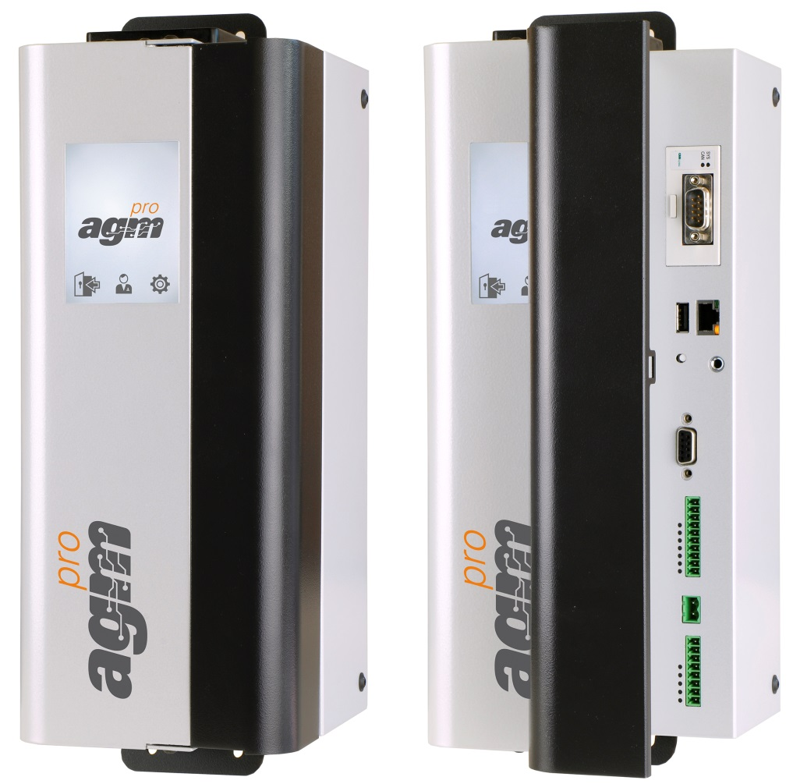
The AGM Pro ultrasonic generator premiered at K 2016 in Düsseldorf is designed for integration in automation lines and special purpose machines for controlling components. Closed on the left, open on the right.
Photos: Rinco Ultrasonics

