Introducing Tosaf’s new anti-fog masterbatch for PE - delivering excellent efficiency and superb transparency in packaging film.
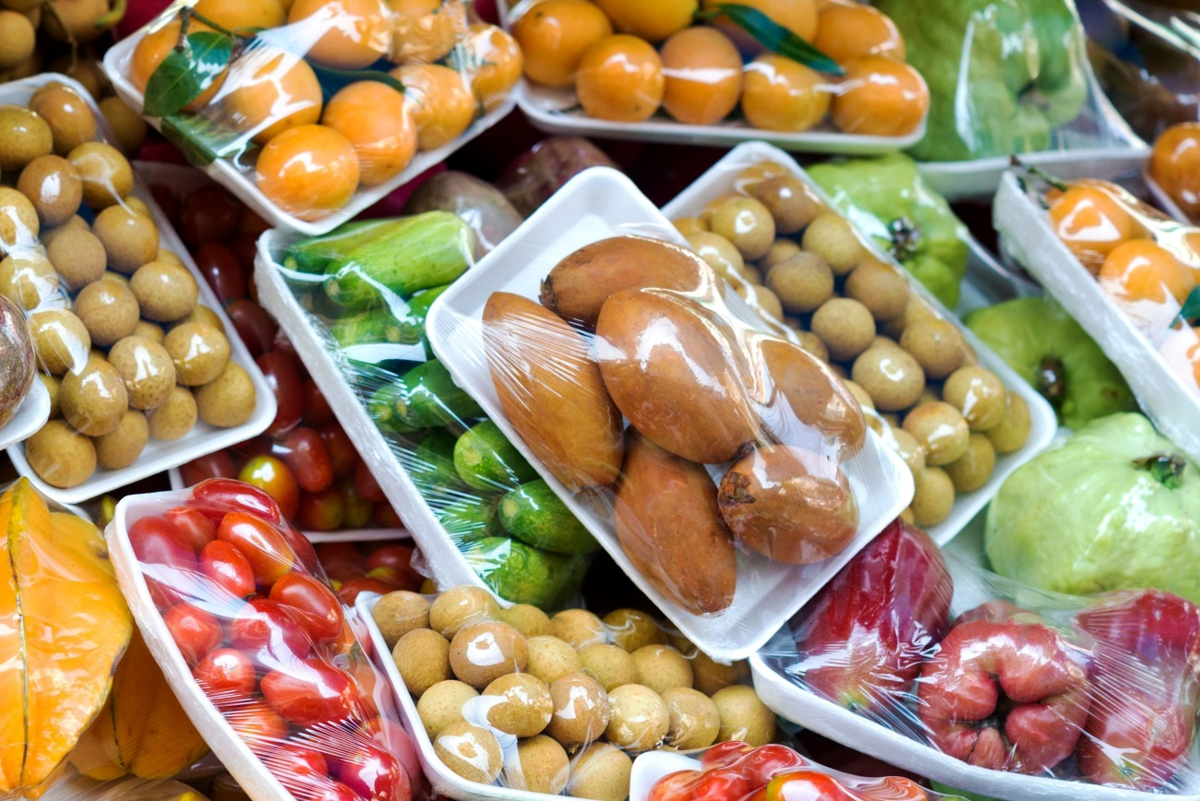
© Big Foot Productions/Shutterstock.com
Alon Tavor, Israel, April, 2018 – Tosaf is proud to announce the launch of AF7380PE, a newly-developed anti-fog masterbatch.
When packaged goods are stored in a refrigerator, water droplets tend to appear on the surface of the packaging film, obscuring the contents from view and seriously degrading overall product quality. To avoid this unwanted result, the surface properties of the film must be altered. The most common way of doing this is through the use of migrating additives.
In over 30 years of working closely with its customers, Tosaf has developed an innovative range of anti-fog masterbatches that help reduce the harmful effects of water drops on packaging film. A wide range of solutions have been developed to suit different applications, for example refrigerated and hot meals packaging, greenhouse films and industrial packaging.
Anti-fog additives for plain polyethylene (PE) films are well known and widely used. However, as film structure becomes more complex and film producers require the same anti-fog masterbatch for a variety of production processes, demand has grown for new solutions and more sophisticated formulations.
Tosaf is proud to present its novel 3rd generation anti-fog masterbatch for polyethylene films, AF7380PE. This masterbatch combines the company’s broad experience working with the most sophisticated anti-fog materials with its profound understanding of the market’s needs. According to Tosaf’s Film Additives R&D Manager, Dr. Evgeni Zelikman, the unique benefits of AF7380PE lie in its combination of excellent anti-fog activity and superb optical properties.
AF7380PE is suitable for a wide range of production processes, from laminated polyethylene films, multi-layer co-ex barrier films produced by blown and cast extrusion, and oriented films produced by double- and triple-bubble production technology.
About Tosaf:
For over three decades, Tosaf has been developing and manufacturing high quality additives, compounds and color masterbatches for the plastics industry. With the aim of providing for its customers’ every need, it has continuously grown and developed its offering, production capacity, and global reach, becoming a truly close to the market, global organization.
Servicing customers in over 50 countries in Europe, North America, South America, Asia and the Middle East, Tosaf has over 1000 employees spread throughout its production sites, warehouses, sales and distribution offices around the world.
Tosaf CEO Amos Megides established the company in Israel in 1986, and still stands at its head, leading and inspiring his team to always uphold the following three pillars: Exceptional service, the highest quality and continuous innovation.
Tosaf’s major shareholders include: Megides Holdings Ltd. and the Ravago Group.
For further information about Tosaf please contact:
Ms. Ronit Segal Hayoon
Global Marketing Communication Manager
Tosaf Compounds Ltd.
Phone: +972 9 8984790
Email: ronith@tosaf.com
Editorial contact, and please send voucher copies to:
Dr.-Ing. Jörg Wolters
KONSENS PR GmbH & Co. KG
Hans-Kudlich-Str. 25, D-64823 Groß-Umstadt,
Phone: +49 6078 9363-13
Email: mail@konsens.de
Dear editors, for your convenience please download the text of this press release from: http://www.konsens.de/tosaf.html

